Grade 10 Construction Box

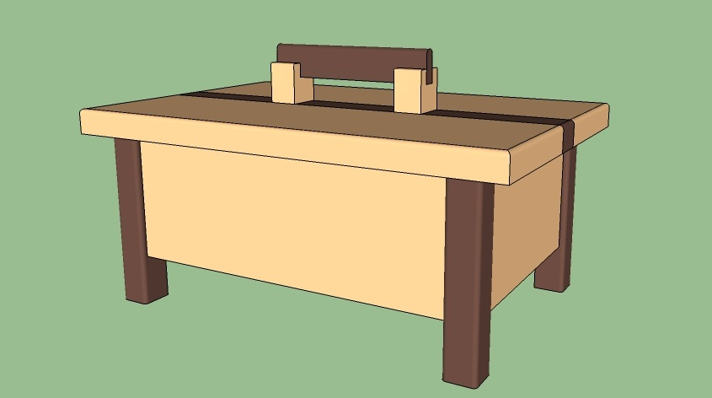

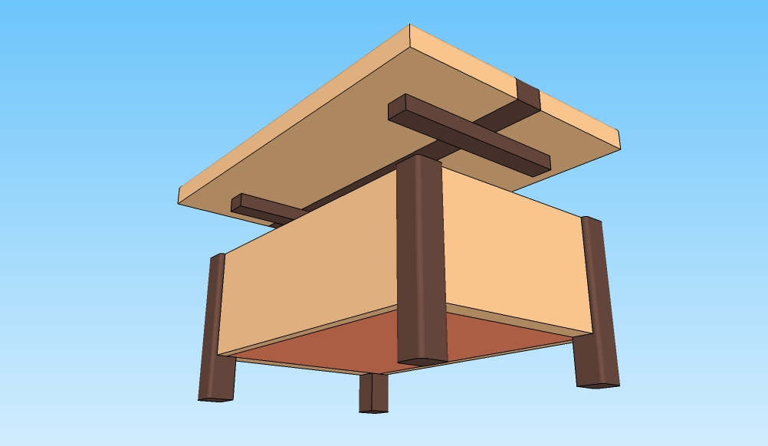

4”
Top Piece - 12¾” Finished
Long Side Piece – 10” Finished | Short Side Piece - 6¼” Finished

17” Rough

3½”

Building the Top

● Cut 2 pieces of 8” wide 4X4 Pine board to 17” on the mitre saw
● Joint the face, cup side down then joint the good edge
● Thickness plain to maximum thickness
● Rip one 3½” and one 4” strip off of each piece on the table saw

Building the Sides

● Plain the 3½” strips to ¾” thick
● Cut a rabbet into the strips by setting up the router to cut ¼” deep and ⅜” wide
● Chop the final lengths to 10” and 6¼” using the cross-sled (each board will give you one 10” and one 6 ¼)

Building the Top (In groups of 7)

● Chop the Willow to 15” in length
● Joint the face of the Willow, cup side down then joint the good edge
● Thickness plain to maximum thickness
● Rip the Willow to 1” strips on the table saw (taking one each)
● Laminate the boards with the Willow strip glued in the middle and the pine on either side (alternating end grain)
● Clamp the pieces and let to dry
● Once the glue is dry, scrape off excess glue and finish plain to ¾”
● Chop to final length of 12 ¾ long
● Router all the sides of the top with a round-over bit (end grain first)

Building the Legs
(Share in groups of 7)

● Joint the face of the Willow, cup side down then joint the good edge
● Plain the Willow to 15/16” thick
● Rip the Willow to 15/16” strips on the table saw (use the small black push stick)
● Using the small 1/8 round over hand plain round over 3 of the edges
● Chop 4 pieces to final length of 4¾” On the cross cut sled using the hold down. NOT HOLDING IT WITH YOUR FINGERS

Assemble the Sides and the Legs

● Apply glue to the ends of the side pieces. Assemble the sides with the legs on the outside corners. Ensure that the top of the side pieces and the top of the legs are flush. Place clamps on the outside of the legs holding it all together. Place a square on the inside of the box and ensure it is clamped square. Make any adjustments before the glue has dried. Once all the glue has dried, chisel off any of the excess glue.

Assembling the lid rails

● Turn project upside down and center the lid by measuring the difference between the lid and the base. Divide this number by two and you will know how much overhand you should have on each side. 5/8 should be the answer if everything is perfect. Mark out with a pencil where the rails go then glue them in place.

Measuring for the plywood bottom

● Measure the width and length of the inside of the rabbet. Talk to the teacher about ripping the ply to width. Chop to final length then use the tracing gauge to duplicate your corners. Draw those out and cut them on the band saw or scroll saw. These will be installed with a little glue and 6 small 1” Common finishing nails.

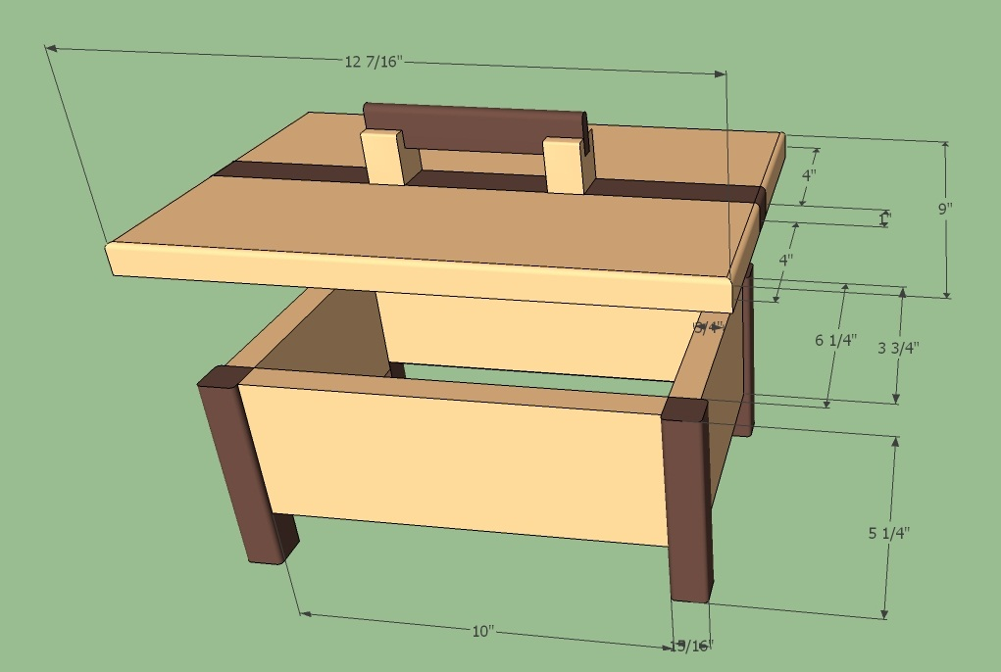

 | Finished |  |  |  | Rough
Part Description | NO. | L | W | T | NO. | L | W | T | Wood | Comments | BF
Long Sides | 2 | 10” | 3 ½” | ¾” | 2 | 10” | 3 ½ | ¾ | Pine
Short Sides | 2 | 6¼” | 3 ½” | ¾” | 2 | 6¼” | 3 ½” | ¾” | Pine
Legs | 4 | 4¾” | 15/16” | 15/16 | 1 | 20” | 15/16 | 15/16 | Willow
Top (Pine) | 2 | 12¾” | 4” | ¾” | 2 | 15” | 4 | MAX | Pine
Top (Willow) | 1 | 12 ¾” | 1” | ¾” | 1 | 15” | 1” | MAX | Willow
Bottom | 1 | To Size |  |  |  | ¼ |  |  | Ply
Handle (Pine) | 2 | 1- 1/16” | 1 ¼” | ⅞” |  | TBD |  |  | Pine | Teacher made
Handle(Willow) | 1 | 5 ¼” | 1” | ⅜” |  | TBD |  |  | Willow

