Technological Education

Course Profile
Custom Woodworking Technology

Grade 11
Destination: Workplace
Course Code: TWJ3E

Developed by: Mr. M. Gordon

.
Course Overview

Custom Woodworking Technology
Code: TWJ3E
Grade: 11
Destination: Workplace

Policy Document: The Ontario Curriculum, Grades 11 and 12, Technological Education, 2009.
Prerequisite: None

Course Description
This course enables students to develop knowledge and skills related to cabinet making and furniture making. Students will gain practical experience using a variety of the materials, tools, equipment, and joinery techniques associated with custom woodworking. Students will learn to create and interpret technical drawings and will plan, design, and fabricate projects. They will also develop an awareness of environmental and social issues related to the woodworking industry, and will explore apprenticeships, postsecondary training, and career opportunities in the field that may be pursued directly after graduation.

Course Notes
A daily log or journal is a useful tool for students to practice their technical writing. It is a useful place to enclose working drawings, cutting lists, and photographs of project work in varying stages of completion. Daily drills can be used to practice essential, often-used skills such as measuring.
Students learn to problem solve through careful analysis, co-operation, and communication. The student-centered, activity-based mode of delivery allows students to:
- develop individual and group skills;
- develop time management skills;
- design and follow an organizational plan with a level of commitment and effort required to complete a task;
- develop the ability to monitor one’s own progress using a variety of record keeping and tracking procedures (logs, journals, and project portfolios).

Fostering Inclusiveness
Technology fairs and showcase events can introduce all students to a wide range of technology activities, and may encourage an interest in technological education. Offering choices from a range of instructional activities or allowing students to select their own projects can help motivate all the students in a classroom by acknowledging the differences in their experiences, attitudes, and interests.
It is important to have open and frank discussions about the kind of workplace environment students are likely to encounter in technological fields. Inviting female and visible minority role models who have had successful careers in various technology sectors to be guest speakers, and involving female and visible minority senior students as mentors, can have a very positive impact on students. Also, exploring strategies that would enable those with different learning and social styles, including Aboriginal students and students from other minority groups, to work effectively together will help establish a more inclusive working environment.

Learning Skills
The development of learning skills and work habits is an integral part of a student’s learning. To the extent possible, however, the evaluation of learning skills and work habits, apart from any that may be included as part of a curriculum expectation in a subject or course, should not be considered in the determination of a student’s grades. Assessing, evaluating, and reporting on the achievement of curriculum expectations and on the demonstration of learning skills and work habits separately allows teachers to provide information to the parents and student that is specific to each of the two areas of achievement.
Student development: Students will learn to set and achieve learning goals both inside and outside school, manage their own learning, and acquire the habits and skills necessary for success both inside and outside school. As students develop the ability to understand how they learn, recognize areas that need improvement, set goals for improvement, monitor their own learning, and become independent learners, they are acquiring the basic habits and skills they will require for lifelong learning.
Interpersonal development: Students will learn to demonstrate self-discipline, take responsibility for their own behavior, acquire the knowledge and skills required for getting along with others both within and beyond the school, and choose ways of interacting positively with others in a variety of situations. They will also learn about thoughtful and non-violent problem resolution, social responsibility, working cooperatively with others, and caring about others.
Responsibility: Fulfils responsibilities and commitments within the learning environment; Completes and submits class work, homework, and assignments according to agreed-upon timelines; Takes responsibility for and manages own behavior
Organization: Devises and follows a plan and process for completing work and tasks; Establishes priorities and manages time to complete tasks and achieve goals; Identifies, gathers, evaluates, and uses information, technology, and resources to complete tasks.
Independent Work: Independently monitors, assesses, and revises plans to complete tasks and meet goals; Uses class time appropriately to complete tasks; Follows instructions with minimal supervision.
Collaboration: Accepts various roles and an equitable share of work in a group; Responds positively to the ideas, opinions, values, and traditions of others; Builds healthy peer-to-peer relationships through personal and media-assisted interactions; Works with others to resolve conflicts and build consensus to achieve group goals; Shares information, resources, and expertise and promotes critical thinking to solve problems and make decisions.
Initiative: Looks for and acts on new ideas and opportunities for learning; Demonstrates the capacity for innovation and a willingness to take risks; Demonstrates curiosity and interest in learning; Approaches new tasks with a positive attitude; Recognizes and advocates appropriately for the rights of self and others.
Self-Regulation: Sets own individual goals and monitors progress towards achieving them; Seeks clarification or assistance when needed; Assesses and reflects critically on own strengths, needs, and interests; Identifies learning opportunities, choices, and strategies to meet personal needs and achieve goals; Perseveres and makes an effort when responding to challenges.
In addition to the specific skills that are developed throughout the course, students learn to:
Independent work:
- attends class regularly and is punctual
- works well without supervision
- completes tasks and assignments on time and with care
- accepts responsibility for own behavior
- follows routines and instructions without supervision
- identifies and pursue learning goals and tasks independently
- responds and participates in a variety of learning activities
- selects learning materials, resources, and activities independently
- persists with tasks
- follows schedules and uses planners to organize time effectively
- adheres to established time lines
- explores, selects, and uses a variety of learning strategies
Initiative:
- welcomes new tasks and seek new opportunities for learning
- responds to challenges
- seeks challenges and takes risks
- are interested in and curious about objects and events
- observes, questions and explores
- seeks additional and new information from library books, CD-ROMs, and other
resources
- identifies problems to solve and conducts experiments
- approaches new learning situations with confidence
- demonstrates a positive attitude towards learning
- generates questions for further inquiry
- investigates and obtains information independently
- develops original ideas and innovative procedures
- attempts a variety of learning activities
- seeks assistance when necessary
- participates in co-curricular activities
Homework completion (work habits)
- follows directions and completes homework on time and with care
- puts forth a consistent effort
- shows attention to detail
- demonstrates interest in and enthusiasm for homework assignments
- organizes materials and equipment for effective use
- begins work promptly
- follows directions and completes tasks
- chooses and uses materials and equipment correctly, safely, and creatively
- uses time efficiently
- perseveres with complex projects that require sustained effort
- attends to the task at hand
- demonstrates flexibility and adaptability
Use of information:
- effectively interprets and synthesizes information
- integrates learning from various subjects/areas of learning
- gathers information effectively, using a variety of techniques and sources
- shows regard for accuracy in analyzing and evaluating information
- recognizes when assignments and projects would benefit from additional information
and identifies the type of information needed
- identifies and uses a variety of facilities, equipment, supplies, evidence, research,
expert opinions, and discussion to gather information and solve problems
- considers all information and alternatives before reaching a conclusion
- demonstrates creativity in assessing information and ideas and draws relevant
conclusions
- organizes information logically and creatively and manages it effectively
- selects appropriate research procedures and uses them effectively
- asks questions to clarify meaning and ensure understanding
- uses information-retrieval technology effectively

Cooperation with others:
- takes turns
- listens to, acknowledges, and considers differing opinions
- willingly works with others
- follows classroom and school procedures
- assumes responsibilities in groups, the classroom, and the school
- helps others
- volunteers
- considers both the immediate and long-term effects of his or her actions on other
Shop Skills:
- safe practice in the classroom
- safe practice and use on the machines
- demonstrates accuracy when cutting, sanding, and milling on machines
- performs imperial and metric measurements
- understands and follows woodworking procedures such as dressing lumber, laminating boards, etc.
- able to distinguish between hardwoods and softwoods
- able to identify various lumber defects
- effectively determines which method of joinery to use
- accurately and precisely performs various methods of joinery
- effectively produces orthographic drawings
- accurately produces material lists
- follows the design process
- demonstrates ability to sand work in preparation for finish
- demonstrates ability to properly apply stain and finish

Safe and Appropriate Use of Equipment and Facilities
Health and safety is of paramount importance in technological education. Students must be made aware that health and safety is everyone’s responsibility at home, at school, and in the workplace. Before using any piece of equipment or any tool, students must be able to demonstrate knowledge of how the equipment or tool works and of the procedures they must follow to ensure its safe use. Personal protective gear must be worn as required.
In this course, students will participate in a 15 hour unit incorporating safety in the classroom and on the machines. Students will become familiar with the safety features of the classroom such as the emergency stop buttons, fire extinguishers, first-aid kits, etc. Students will also receive a demonstration of safe practice on each piece of machinery followed by a guided one-on-one instructional practice. Each student will then receive a safety passport that will document, with signatures and dates that they watched the demonstration of safe practice on a specific piece of machinery then participated on the one-on-one teacher guided demonstration.

Equipment Requirements
The units in this course profile rely upon the availability of a wide range of ….The chart below provides an overview of the equipment, resources and facilities required in each unit.
Equipment and Facilities | Unit 1 | Unit 2 | Unit 3 | Unit 4 | Unit 5 | Unit 6 | Unit 7
Safety Equipment
Safety Goggles | X | X | X | X | X | X | X
Hearing Protection | X | X | X | X | X | X | X
Closed Toed Shoes | X | X | X | X | X | X | X
First Aid Kit | X | X | X | X | X | X | X
Eye Wash Station | X | X | X | X | X | X | X
Fire Extinguishers | X | X | X | X | X | X | X
Emergency School Phone | X | X | X | X | X | X | X
Hand Tools (not powered) and Materials
Tape Measures | X | X | X | X | X | X | X
Squares | X | X | X | X | X |  | X
Jack plane | X |  | X | X |  |  | X
Block plane | X |  | X | X |  |  | X
Hammer | X |  | X | X |  | X | X
Utility Knife | X |  | X | X |  |  | X
Chisels | X |  |  | X |  |  | X
Levels | X | X |  | X |  |  | X
Screwdrivers | X |  |  |  |  |  | X
Sliding T-Bevels | X |  |  | X | X |  | X
Backsaw | X |  |  | X |  |  | X
Sandpaper | X |  |  |  |  | X | X
Pencil | X | X | X | X | X | X | X
Marking Gauge | X | X |  | X |  |  | X
Kreg Jig | X |  |  | X |  |  | X
Dado Blades | X |  |  | X |  |  | X
Drill Bits | X |  |  | X |  |  | X
Biscuits | X |  |  | X |  |  | X
Wood Glue | X |  | X | X |  |  | X
Countersink | X |  |  | X |  |  | X
Flush-Cut Saw | X |  |  | X |  |  | X
Wood File | X |  |  | X |  |  | X
Hand Tools (powered)
Drills | X |  |  |  |  |  | X
Palm Sanders | X |  |  |  |  | X | X
Jig Saw | X |  |  |  |  |  | X
Biscuit Joiner | X |  |  | X |  |  | X
Stationary Tools
Mitre Saw | X |  | X | X |  |  | X
Table Saw | X |  | X | X |  |  | X
Scroll Saw | X |  |  | X |  |  | X
Band Saw | X |  |  | X |  |  | X
Wood Lathe | X |  |  |  |  |  | X
Router | X |  |  | X |  |  | X
Jointer | X |  | X | X |  |  | X
Surface Planer | X |  | X | X |  |  | X
Mortiser Machine | X |  |  | X |  |  | X
Drill Press | X |  |  | X |  |  | X
Finish Products
Wood Conditioner | X |  |  |  |  | X | X
Wood Stain | X |  |  |  |  | X | X
Wood Finish (Varnish) | X |  |  |  |  | X | X

Units: Titles and Times
Unit 1 | Machine and Shop Safety | 15 Hours
Unit 2 | Measurement | 10 Hours
Unit 3 | Woodworking | 15 Hours
Unit 4 | Joinery | 15 Hours
Unit 5 | Project Design and Layout Package | 20 Hours
Unit 6 | Wood Finish | 10 Hours
Unit 7 | Culminating Project | 25 Hours
Total |  | 110 hrs

Unit Overviews

Unit 1: Machine and Shop Safety
Time: 15 hours
Unit Description
Safety is the main and most important component in the classroom. In this unit, students will learn safe practices in the classroom and on the machines. They will learn safe practices in the classroom by identifying various safety features and components such as emergency stops, fire extinguishers, first-aid kits, etc. Students will also be given a full one-on-one demonstration and guided practice through each piece of machinery all while constructing a small project such as a Wine Bottle Holder or Ipod Docking Station. Students will also identify and name the various parts of each piece of machinery. The unit will be concluded with a test that will include questions on various classroom and machine safety information and procedures.
Unit Overview Chart
Activity # | Activity Title/Name | Learning Expectations  - Overall  - Specific | Assessment Categories | Tasks
1.1 | Shop Layout Activity | Specific - E 1.1, 1.2, 1.3,  Overall – E.1. | Knowledge/ Understanding | Students will become familiar with their surroundings by drawing out a map of the layout of the shop. This will include fire extinguishers, first aid kits, emergency stops, machines, etc.
1.2 | Machine Demonstrations through Wine Bottle Holder or Ipod Docking Station Activity | Specific - A 2.2, E 1.4, 1.5,  Overall – A.2,  E.1, | Application | Students will learn and practice safe use of each machine through a guided demonstration all while constructing a small project.
1.3 | Machine Parts Activity | Specific - A 2.1, 3.3  Overall – A.2, 3. | Thinking and Inquiry | Students will identify the various parts for each machine
1.4 | Machine and Shop Safety Test | Overall –  A.2, 3, E.1 | Knowledge and Understanding, Application, Thinking and Inquiry | Students will be tested on various machines and shop safety

Unit 2: Measurement
Time: 10 hours
Unit Description
Measurement is a key factor and skill that is used every day in the trades. In this unit students will explore and learn metric and imperial measurement through on-going projects and worksheets. Besides working through various worksheets, students will also learn to add and subtract measurements from the various steps and procedures of their projects.

Unit Overview Chart
Activity # | Activity Title/Name | Learning Expectations  - Overall  - Specific | Assessment Categories | Tasks
2.1 | Classroom Measurements | Specific - A 2.2  Overall – A.2. | Application | To introduce measurement, students will measure various items in the classroom
2.2 | Imperial and Metric Measurement | Specific - B 4.1, 4.2 Overall – B.4. | Knowledge and Understanding, Thinking and Inquiry | Students will complete a worksheet with various imperial and metric measurements
2.3 | Adding and Subtracting Measurement | Specific – B 4.1, 4.2  Overall – B.4. | Knowledge and Understanding, Thinking and Inquiry | Students will work through a worksheet with various additions and subtractions of measurements
2.4 | Measurement Test | Overall – A.2. B.4. | Application, Knowledge and Understanding, Thinking and Inquiry | Students will complete a test on various metric and imperial measurements, as well as, adding and subtracting various measurements.

Unit 3: Woodworking
Time: 15 hours
Unit Description
There are steps and procedures for any kind of manufacturing or fabrication process. Woodworking is also the same way. In this unit, students will learn and be able to identify various wood deformations and distinguish between hardwoods and softwoods. They will also learn the process of machining rough lumber into workable finished lumber called dressing. They will then learn how to glue and laminate boards together in order to get the desired widths, eliminating cupping. Students will be evaluated on their woodworking knowledge through a test involving various questions from each activity.

Unit Overview Chart
Activity # | Activity Title/Name | Learning Expectations  - Overall  - Specific | Assessment Categories | Tasks
3.1 | Dressing Lumber and Wood Deformations | Specific - A 1.3, 3.1, 3.2, 3.3, C 1.2, E 1.4  Overall – A.1, 3. C. 1, E.1. | Knowledge and Understanding, Communication | Students will learn various wood deformations and how to dress lumber through their safety project and the DVD Cabinet
3.2 | Gluing and Laminating Boards | Specific – A 3.1, 3.2, 3.3, C 1.5, E 1.4  Overall - A. 3. C. 1, E.1 | Application, Communication | Students will learn how to glue and laminate boards while constructing their DVD Cabinets
3.3 | Hardwoods and Softwoods | Specific – A 1.2,  Overall – A. 1 | Knowledge and Understanding | Students will work through a worksheet on hardwoods and softwoods
3.4 | Woodworking Test | Overall – A. 1, 3. C. 1. E. 1. | Knowledge and Understanding, Communication, Application | Students will complete a test on various components of dressing lumber, wood deformations, gluing and laminating, and softwoods and hardwoods.

Unit 4: Joinery
Time: 15 hours
Unit Description
Joinery is not only an aesthetic feature and pleasing to the eye, but it also provides strength and durability to any project. It is a major feature and staple of custom woodworking that can make a good project into a great project. In this unit, students will learn various joints performed in woodworking through practicing on scrap pieces of wood and through constructing their DVD Cabinet projects. The skills learned will be greatly beneficial to them when it comes time to construct their culminating projects. The students will be evaluated on a Joint Frame Project that will incorporate the joints they have previously learnt through practicing on scrap pieces of wood and their DVD Cabinet.
Unit Overview Chart
Activity # | Activity Title/Name | Learning Expectations  - Overall  - Specific |  | Assessment Categories |  | Tasks
4.1 | DVD Cabinet |  | Specific - A 2.2, 2.3, 3.2, B 3.3, 3.4, 4.1 C 1.2, 1.4, 1.5, 1.6, E 1.4  Overall – A. 2,3, B. 3,4, C. 1, E.1 |  | Communication,  Application, |  | Students will learn and perform various joints in constructing their DVD Cabinets
4.2 | Joinery 101 | Specific – A 2.2, 2.3, 3.2, B 4.3, C 1.4, 1.6, E 1.4  Overall – A. 2,3, B. 4, C. 1, E. 1 |  | Communication, Application, |  | Students will learn and practice various joints on scrap wood
4.3 | Joint Frame Project | Overall – A. 2,3, B. 3,4, C. 1, E. 1 |  | Communication, Application, |  | Students will construct a frame using various joints

Unit 5: Project Design and Layout Package
Time: 20 hours
Unit Description
In many technological fields, open-ended problem-solving processes that involve the full planning and development of products or services to meet identified needs are often referred to as the “Design Process”. In this unit, students will learn and practice the design process with their DVD Cabinet. They will also learn how to produce orthographic drawings and a material list for their DVD Cabinet. They will then be evaluated on a package they will put together for their culminating project that will include the design process, orthographic drawings, material list, a reflection paper of their project, and careers in the construction trade.

Unit Overview Chart
Activity # | Activity Title/Name | Learning Expectations  - Overall  - Specific | Assessment Categories | Tasks
5.1 | DVD Cabinet Drawings | Specific – B 2.1, 2.2, 2.3  Overall – B. 2 | Knowledge and Understanding, Application | Students will create orthographic drawings for their DVD Cabinet
5.2 | DVD Cabinet Materials List | Specific – B 3.2, 4.1, 4.5, D 1.4  Overall – B. 3, 4, D. 1 | Application, Thinking and Inquiry | Students will produce a material list for their DVD Cabinet
5.3 | DVD Cabinet Design Process | Specific – A 3.3, 3.4, 3.5, B 1.1, 1.3, 1.4, 1.5, 3.1, C 1.1,  Overall – A.3,  B. 1, 3, C. 1 | Communication, Thinking and Inquiry | Students will learn and go through the design process for their DVD Cabinet
5.4 | Culminating Project Package | Overall – A. 3, B. 1, 2, 3, 4, C. 1, D. 1, 2, E. 2 | Communication, Thinking and Inquiry, Application, Knowledge and Understanding | Students will create a package for their culminating project that will include orthographic drawings, material list, the design process, reflection paper, and careers in the trade

Unit 6: Wood Finish
Time: 10 hours
Unit Description
A well applied, beautiful finish can intensify any project no matter the skill level involved. A finish product can also add personalization, adding character into any project. In this unit, students will learn the steps of properly sanding their projects in preparation for stain by practicing on their Wine Bottle Holder or Ipod Docking Station. They will then learn how to properly apply stain through practicing again on their Wine Bottle Holder or Ipod Docking station. Students will then be evaluated on the overall finish of their DVD Cabinet.
Unit Overview Chart
Activity # | Activity Title/Name | Learning Expectations  - Overall  - Specific | Assessment Categories | Tasks
6.1 | Sanding Wine Bottle Holder or Ipod Docking Station | Specific – A 1.3, C 2.1, E 1.5  Overall – A. 1, C. 2, E. 1 | Communication, Application | Students will learn and practice how to properly sand projects through working on their Wine Bottle Holder or Ipod Docking Station
6.2 | Staining Wine Bottle Holder or Ipod Dockng Station | Specific – A 1.4, C 2.2, E 1.1, 1.5  Overall – A.1, C. 2, E. 1 | Communication, Application | Students will learn and practice how to properly stain projects through working on their Wine Bottle Holder or Ipod Docking Station
6.3 | DVD Cabinet Finish | Overall – A.1, C. 2, E. 1 | Communication, Application | Students will sand and stain their DVD Cabinet

Unit 7: Culminating Project
Time: 25 hours
Unit Description
In this unit, students will assemble and combine all the knowledge they have gained throughout this course and construct a project of their choice. Each project will be approved by the teacher to ensure that it is skillfully challenging, yet accomplishable. Students who do not know what they want to construct, can consult a list of suggested projects in which they may choose from. Other students may also choose to construct a community based project that is equally or more challenging. Again, all projects are to be approved by the teacher. For their culminating project, students must display and follow all safety protocols when in the classroom and on the machines. They must follow the necessary procedures of woodworking and it must include various forms of joinery. It must also be finished with any stain or other finishing product of their choice and they must include a project package that contains a material list, orthographic drawings, the design process, a paper on related trades in carpentry, and a reflection paper of the project.

Unit Overview Chart
Activity # | Activity Title/Name | Learning Expectations  - Overall  - Specific | Assessment Categories | Tasks
7.1 | Machine and Shop Safety | Overall – A.2, 3, E. 1, | Knowledge and Understanding, Application, Thinking and Inquiry | Students will work safely in the classroom and on the machines when working on their culminating project
7.2 | Measurement | Overall – A.2, B. 4, | Application, Knowledge and Understanding, Thinking and Inquiry | Students will use measurement constantly when working on their culminating projects
7.3 | Woodworking | Overall – A.1, 3, C. 1, E. 1, | Knowledge and Understanding, Communication, Application | Students will follow the processes of woodworking when working on their culminating projects
7.4 | Joinery | Overall – A.2, 3, B. 3, 4, C.1, E. 1, | Communication, Application, | Students will use various joints when constructing their culminating projects
7.5 | Project Design and Layout Package | Overall – A.3, B.1, 2, 3, 4, C. 1, D. 1, 2, E. 2, | Communication, Thinking and Inquiry, Application, Knowledge and Understanding | Students will create a package for their culminating projects that will include material list, orthographic drawings, design process, reflection paper, and careers in the trade
7.6 | Wood Finish | Overall – A.1, C. 2, E. 1, | Communication, Application | Students will finish their culminating projects through sanding then applying stain.

Teaching/Learning Strategies

Students use and explore Woodworking technologies by means of the following learning strategies:
Application – creation of technological products for identified purposes;
Brainstorming – group generation of initial ideas expressed without criticism or analysis;
Collaborative/Cooperative Learning – small group learning and decision making providing high levels of student engagement and interdependence;
Conferencing/Discussion – student-to-student discussion and teacher-to-student conferencing to encourage confidence and motivation to success in all learners;
Design Process – the stages of development of a product or process, including developing a focus, developing a framework, choosing the best solution, implementing a plan and reflecting on the process and the product;
Independent Study – exploration and research of a topic interesting to students.
Problem Solving – identifying and working through a problem;
Report/Presentation – oral, visual, written and electronic presentation of researched topic to class;
Teachers may seek the collaboration of other teachers in interdisciplinary and cross-curricular projects (for example in the production of multimedia or interactive presentations). Teachers should seek the collaboration and participation of Guidance personnel during Unit 1.

Assessment & Evaluation of Student Achievement
The assessment techniques described below focus on both the process and product of student learning.

Assessment/Evaluation Techniques
Paper-and-Pencil
- Quizzes and tests
- Worksheets
- Project proposals
- Final written evaluation
Performance Assessment
- Skills demonstrations
- Finished product
Personal Communication
- Conferencing
- Student-teacher
- Teacher-group
- Daily activity log or journal

Assessment Tools
- Checklists
- Marking schemes
- Rubrics
- Anecdotal comments with suggestions for improvement
- Rating scales

Purposes of Assessment
- Diagnostic – occurs at the beginning of a term, unit of study, or whenever information about prior learning is useful.
- Formative – during the learning process, provides ongoing feedback to the teacher about the quality of learning and the effectiveness of instruction.
- Summative – is usually carried out at the end of a learning process (may include feedback and/or judgment).

Evaluation of Student Achievement
Students are formally evaluated on their demonstration of curriculum expectations using the categories of skills and knowledge set out in the Achievement Chart. Checklists are used to provide information about the operational steps of the production process (such as the completion of planning documents) and an ongoing means of monitoring the level of achievement attained. Rating scales and rubrics describe the look and feel of completed products. All evaluation tools should be available to students at the beginning of an activity to provide information about task requirements and the features of exemplars. Teacher/student discussions during pre-production, production and post-production can clarify standards and expectations as well as provide a way of monitoring progress. The inclusion of informal opportunities for peer and self-assessment can promote in students a sense of responsibility, accountability, and growth. Written tests and question sheets are effective in the evaluation of required knowledge. The vocabulary used in test questions should reflect that used in the learning situation. The option for oral testing and student demonstrations of acquired skills should also be used. Although students are encouraged to write answers in proper sentence form, diagrammatic answers are effective assessment instruments in technological education. In their planning and implementation of projects, work assignments, and problem-solving activities, students demonstrate their ability to combine skills and knowledge successfully in practical tasks. Seventy per cent of the grade will be based on assessments and evaluations conducted throughout the course. Thirty per cent of the grade will be based on a final evaluation in the form of an examination, performance, essay, and/or other methods of evaluation.

Accommodations
The teacher consults individual student IEPs for specific direction on accommodations for individuals. The teacher uses a range of teaching/learning strategies to accommodate the needs of all students. Exceptional students benefit from accommodations in the overall activity criteria, as well as teacher and peer assistance when appropriate. Written tests are designed to suit students’ reading and writing levels. The teacher adapts teaching strategies to accommodate learning styles. These may include:
- verbal instead of written tests;
- demonstrations of acquired skills instead of written evaluations;
- providing rewrite opportunities when appropriate;
- conferencing/discussion – student-to-student discussion and teacher-to-student conferencing to encourage confidence and motivation;
- small-group learning;
- flexible timelines;
- adapting handouts;
- peer tutoring;
- enrichment and extension activities.

Resources
Units in this Course Profile make reference to the use of specific texts, magazines, films and websites. The teacher must consult board policies regarding the use of any copyrighted materials. Before reproducing materials for student use from printed publications, the teacher must ensure that the school board has a Cancopy licence and that this licence covers the resources to be used. Before screening videos/films with the students, the teacher must ensure that the board/school has obtained the appropriate public performance videocassette licence from an authorized distributor, e.g., Audio Cine Films Inc. Note: much of the material on the Internet is protected by copyright. The person or organization that created the work usually owns the copyright. Reproduction of any work or substantial part of any work on the Internet is not allowed without the permission of the owner.
Each activity in this profile lists specific resources that may include textbooks, training manuals, magazines, websites, multimedia and presentation packages, videos, online tutorials and career/industry sources. Below is a comprehensive list of resources referenced in the activity descriptions for each course unit.

Books

Feirer, John L., and Mark D. Feirer. Wood Technology & Processes. Peoria, IL: Glencoe McGraw-Hill, 2002. Print.

OSS Considerations
Grade 12 Communications Technology, College/University Preparation is designated as a Technological Education, Part A, Broad-Based Technology program. The philosophy that underlies the teaching of broad-based technology is that students learn best by doing. University/College Preparation courses are designed to equip students with the knowledge and skills they require to meet the requirements for admission to college and university programs. (See Ontario Curriculum, Grades 9 to 12: Program Planning and Assessment, 2000 for a description of the different types of secondary school courses).
Ontario secondary school graduates are expected to be technologically literate as stated in Ontario Secondary Schools, Grades 9 to 12: Program and Diploma Requirements, 1999. They should be able to understand and apply technological concepts, use computers in various applications and analyse the implications of a wide range of technologies for individuals and society.
To ensure that all students in the province have equal opportunity to achieve their full potential, the education system must be free from discrimination and provide all students with a safe and secure environment so that they can participate fully and responsibly in the educational experience. Schools are also required to adopt measures to provide a safe environment for learning that is free from harassment of all types, violence and expressions of hate. Anti-discrimination education, equity/social justice issues, conflict resolution/violence prevention, community partnerships and faith development are addressed in the course. These support the Ontario Secondary School board policies as well as the Ontario Catholic School Graduate Expectations. For more information, consult Section 7.13 Anti-discrimination Education of the OSS document.
Career exploration is a component of all units and is aligned with Choices Into Action: Guidance and Career Education Program Policy for Elementary and Secondary Schools, 1999. Students have a broad range of career exploration opportunities.
Unit 4: Joinery
Time: 15 hours

Unit Description
Joinery is not only an aesthetic feature and pleasing to the eye, but it also provides strength and durability to any project. It is a major feature and staple of custom woodworking that can make a good project into a great project. In this unit, students will learn various joints performed in woodworking through practicing on scrap pieces of wood and through constructing their DVD Cabinet projects. The skills learned will be greatly beneficial to them when it comes time to construct their culminating projects. The students will be evaluated on a Joint Frame Project that will incorporate the joints they have previously learnt through practicing on scrap pieces of wood and their DVD Cabinet.

Unit Overview Chart
Activity # | Activity Title/Name | Learning Expectations  - Overall  - Specific | Assessment Categories | Tasks
1.1 | DVD Project Joinery | Specific - A 2.2, 2.3, 3.2, B 3.3, 3.4, 4.1 C 1.2, 1.4, 1.5, 1.6, E 1.4  Overall – A. 2,3, B. 3,4, C. 1, E.1 | Communication, Application, Thinking and Inquiry, Knowledge and Understanding | Students will learn and perform various joints in constructing their DVD Cabinets
1.2 | Joinery 101 | Specific – A 2.2, 2.3, 3.2, B 4.3, C 1.4, 1.6, E 1.4  Overall – A. 2,3, B. 4, C. 1, E. 1 | Communication, Application, Knowledge and Understanding | Students will learn and practice various joints on scrap wood
1.3 | Joint-Frame Project | Overall – A. 2,3, B. 3,4, C. 1, E. 1 | Communication, Application, Thinking and Inquiry, Knowledge and Understanding | Students will construct a frame using various joints

Assessment & Evaluation of Student Achievement
Task/Product | Tool | Purpose | Assessment Categories
DVD Project Joinery | Peer and Self-Assessment Rubric | Formative | Communication, Application, Thinking and Inquiry, Knowledge and Understanding
Joinery 101 | Checklist | Formative | Knowledge and Understanding, Communication, Application
Joint-Frame Project | Rubric | Summative | Communication, Application, Thinking and Inquiry, Knowledge and Understanding

Activity 1.1: DVD Project
Time: 9 hours

Description:
During the course, students will construct a DVD Cabinet from which they will learn various woodworking skills such as joinery. The DVD Cabinet project will include various joints such as a mortise and tenon, dado, biscuit and rabbet joints. Students will not only use this project to practice their joinery in preparation for the summative unit task, but they will also gain practice in preparation for their culminating projects. This activity will solely focus on the joinery in the DVD Cabinet as other components of the construction, such as dressing the lumber, will be focused in the other units.

Strand(s) & Learning Expectations
Strand(s): Fundamentals, Skills, Technology, the Environment, and Society, Professional Practice and Career Opportunity
Overall Expectations
A. 2, 3 / B. 3, 4, / C. 1 / E.1
Specific Expectations
A 2.2, 2.3, 3.2, / B 3.3, 3.4, 4.1 / C 1.2, 1.4, 1.5, 1.6, / E 1.4

Accommodations
The teacher consults individual student IEPs for specific direction on accommodation and adapts the activity and teaching strategies to meet the needs of individual students. Students’ individual needs may be accommodated through an adaptation of the design and/or production stages of the activity.

DVD Cabinet - Joinery
Activity Plan

Technological Education Discipline: Woodworking Technology – TWJ3E

Activity Name: DVD Cabinet

Unit #: 4 - Joinery

Activity #: 1

Description: During the course, students will construct a DVD Cabinet from which they will learn various woodworking skills such as joinery. The DVD Cabinet project will include various joints such as a mortise and tenon, dado, biscuit, pocket screws, and rabbet joints. Students will not only use this project to practice their joinery in preparation for the summative unit task, but they will also gain practice in preparation for their culminating projects. This activity will solely focus on the joinery as other components of the construction, such as dressing the lumber, will be focused in the other units.
Students will learn how to perform a rabbet-joint by cutting the back edges of their gables so back of the cabinet can be installed seamlessly. They will also learn how to cut a dado joint in their gables that will serve as support for their shelves. They will then learn how to cut a mortise and tenon that will be used to assemble their face frame. Next, they will then learn how to cut a biscuit joint that will attach their face frame to their gables. Finally, they will use a Kreg Jig to install their top on the gables using pocket screws.

Assessment and Evaluation: Both Assessment As Learning and Assessment For Learning. These assessments will be supported by a peer and self-assessment rubric about the students work and how improvements might be made. These skill areas will be assessed; Knowledge/Understanding, Thinking /Inquiry/Problem Solving, and Application

Overall Curriculum Expectations: A. 2, 3 / B. 3, 4, / C. 1 / E.1

Specific Curriculum Expectations: A 2.2, 2.3, 3.2, / B 3.3, 3.4, 4.1 / C 1.2, 1.4, 1.5, 1.6, / E 1.4

Prior Learning: All students should have some prior knowledge of: Safety in the classroom, Personal safety knowledge (PPE), Safe use of the machines and hand tools, Knowledge of accurate measurement, Able to dress lumber, Knowledge of proper glueing procedures.

Enduring Understandings and Essential Skills: Problem Solving, Various Joinery Techniques, Knowledge and Use of Jigs

Activity Procedure: Through the woodworking unit, students will have glued, laminated, and planed their boards to the proper sizes to create their 2 gables, shelves, back piece, pieces for their face frame, and their top.
-Rabbet Joint: Students will cut a rabbet into the back of their gables to install their back piece seamlessly. They can do this with the correct router bit or on the table saw with dado blades. They will begin by setting up dado blades on the table saw. Then, they will set the height of the blades to half the thickness of the gables. They will then set the outside of the blades to the fence to the exact thickness of the back piece. Students will run both of their gables through the table saw.
-Dado Joint: Students will cut a Dado joint in their gables that will support their shelves. The first thing students will do is install the dado blades on the table saw. Students will reassure that their shelves are the exact same size as the width of the dado bits installed. If the shelves are slightly wider than the dado bits, students will have to perform a second pass. To make the process more efficient, I would suggest making a jig or Dado sled. Pictures will be provided for reference. Next, students will setup a block of wood or “stop” that will be clamped onto the sled to ensure each gable is cut exactly the same. Using the handout provided, students will set the stop on the sled to the measurements of the height of the shelves. They will then set the height of the dado blades to half the thickness of their gables. Afterwards, ensuring their gables are against the stop, students will cut both of their pieces. This will create a cut in which their shelves will be installed. After the students have made all the cuts for their shelves in both of their gables, they will then glue, insert the shelves in the dados, and clamp their project.
-Mortise and Tenon: Students will use a Mortise and Tenon joint to assemble their face frames. First they will cut a 3/8” mortise into a scrap piece of wood that will be used as a reference. Then, they will use the same sled and dado blades used in the dado joints. Students will clamp a stop at the edge of the blade that will set the length of the tenon. They will then layout the thickness needed for their tenon using the mortise on the scrap piece of wood as a reference. Students will set the blade slightly lower than needed and raise the blade after each pass until the tenon fits snuggly into the mortise. They will flip the piece after each pass to ensure the tenon is cut around all sides. The students will continue this process for as many tenons as required. Once they are all cut-out, students will use their tenons to layout their mortises using the handout as reference. Once the mortises have been laid-out, students will perform a fit test to ensure everything fits correctly before they begin to glue their face frame. Once satisfied, students will glue, assemble, and clamp their face frame ensuring it is square.

Activity Procedure Continued:
-Biscuit Joint: Students will use biscuit joints to attach their face frames to their gables. They will first begin by putting the face frame on the gables and centering it until there is equal distance on either side. Holding the face frame down, the will scribe a line down outside of the gables on the underside of the face frame and mark 2 lines, on each gable, that connect from the gable and face frame. These lines will serve as reference when cutting the biscuits. Students will then remove the face frame from the gables. To cut the biscuits in the face frame, they will align the fence of the biscuit joiner so that it is flush with the line drawn on, and centered within the mark that connects to the gables. They will turn the machine on, push down and that will create the first cut. They will continue this process for the 3 other marks they have made. To cut the biscuits in the gables, students will align the fence of the biscuit joiner with the outside edge of the gable and centered within the mark that again connects to the face frame. The students will make the cut, and then proceed to cut the other 3 biscuits. Once everything has been cut, students will insert biscuits into the joints and perform a dry test to ensure everything lines up before it is glued. Once satisfied, students will glue, assemble, and clamp the face frame onto their gables ensuring that it is also glued square.
-Pocket Screws: Students will use a Kreg Jig and pocket screws to install their top onto their gables. Before the shelves have been glued and installed, they will insert the top of their gables into the Kreg jig and drill 2 pocket holes in the top of each piece. After the cabinet has been assembled and glued, the students will begin by centering their top on their gables, ensuring there is equal distance on either side. While holding their tops down onto the gables, they will use a screwdriver to drive the screws into the top, securing it. This process will be continued until everything is screwed in.

Materials: Pencil, Glue, Screws, Biscuits, DVD Cabinet (Face Frame, Gables, Back Piece, Shelves, Top)

Tools and Equipment: : Table saw, Mitre Saw, Mortiser Machine, Marking Gauge, Combination Square, Tape Measure, Biscuit Joiner, Kreg Jig, Dado Blades, Table Saw Sled, Screwdriver

Accommodations and Modifications: If necessary, extra time can be allotted for students and repeating instructions for clarification. Large print handouts.

Terminology, Literacy and Numeracy: Math with metric and imperial measuring systems. Students will be reading and following instructions.
Terminology: Dado joint, Biscuit joint, Pocket screws, Kreg jig, Rabbet joint, Stops, Mortise and Tenon, Table Saw Sled

Additional Resources: Students will be required to follow the hand-out that contains the requirements and specification of the DVD Cabinet. Students will be required to review the safe operation procedures handout for all tools and equipment used.

Activity Review: (Review the activity after it has been completed by students, what, could be improved?)

__________________________________________________________________________________________________________________________________________________________________________________________________________________________________________________________________________________________________________________________________________________________________________________________________________________________________________________________________________________________________________________________________________________________________________________________________________________________________________________________________________________________________________________________________________________________________________________________________________________________________________________________________________________

Dado Sled

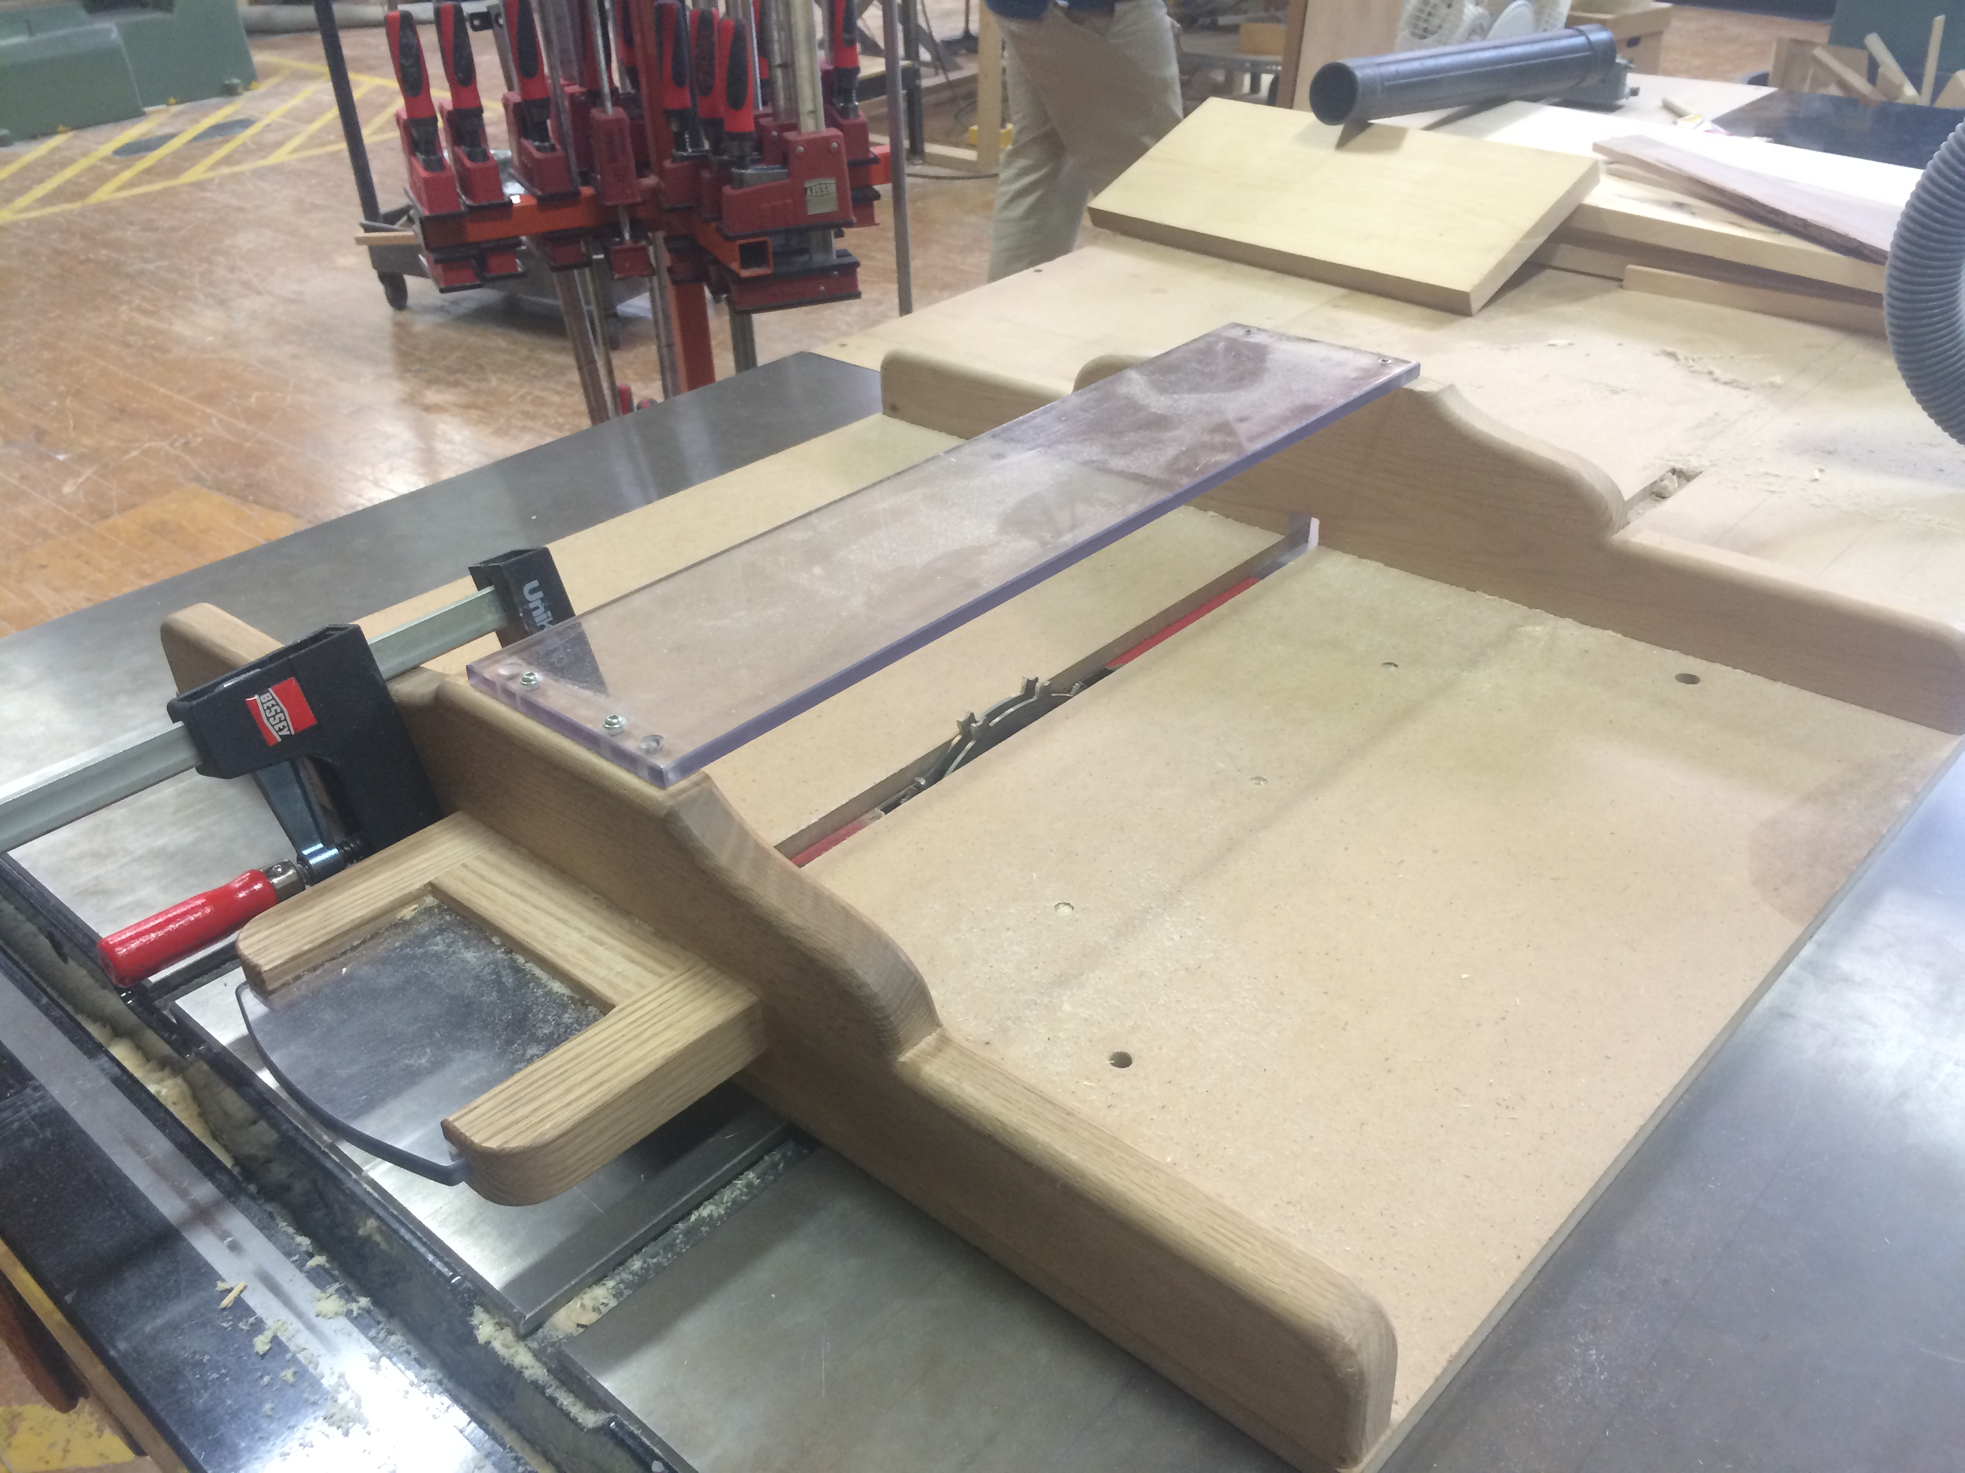
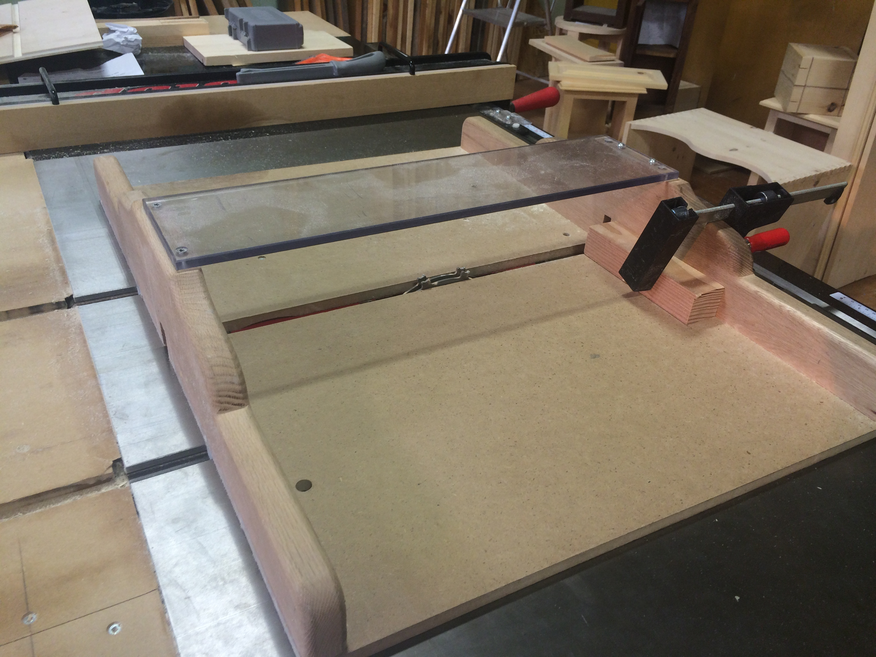

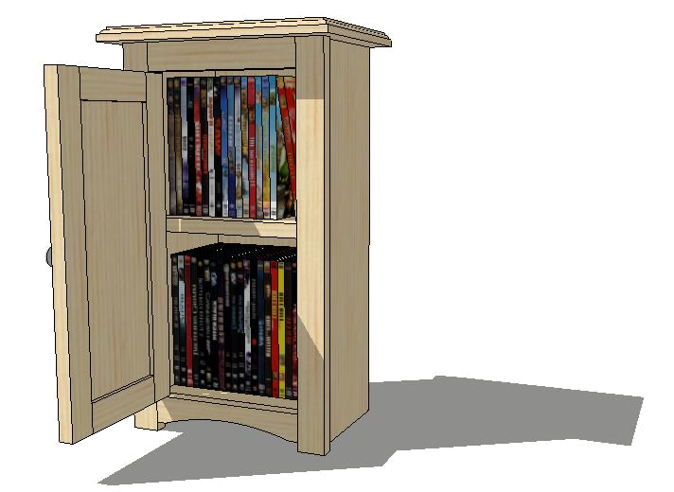
Cabinet

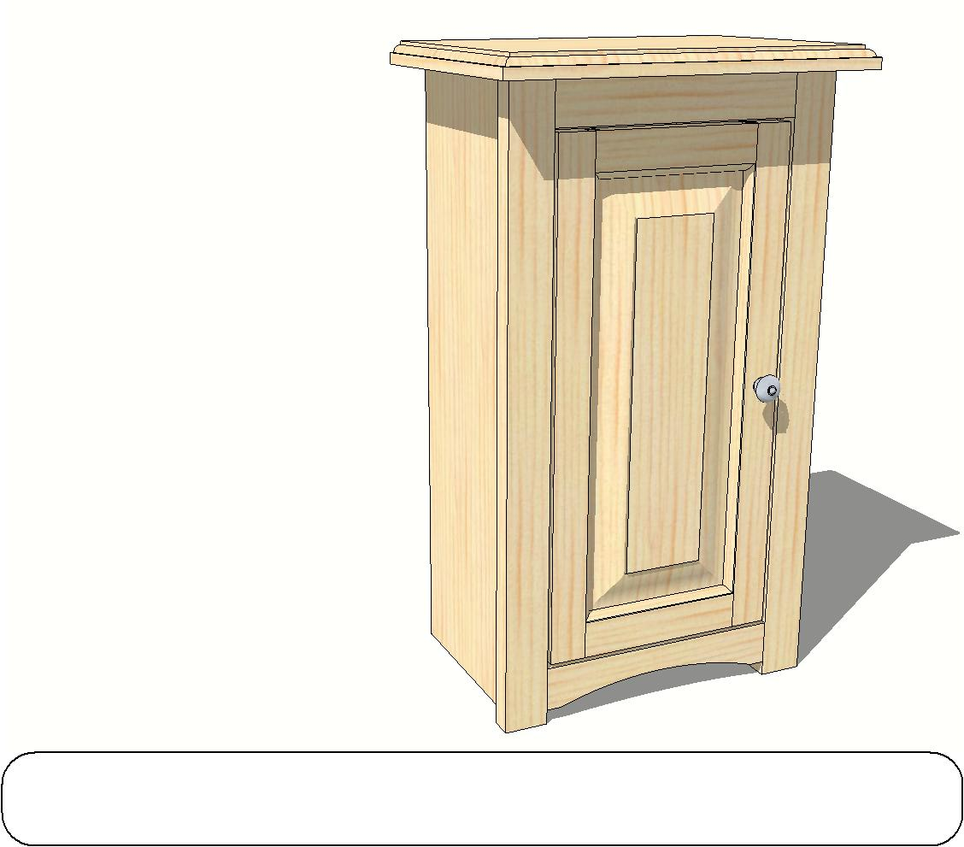
Pine DVD
Pine DVD Cabinet
Pine DVD Cabinet | Scale: | NTS
Overview | February 14, 2012

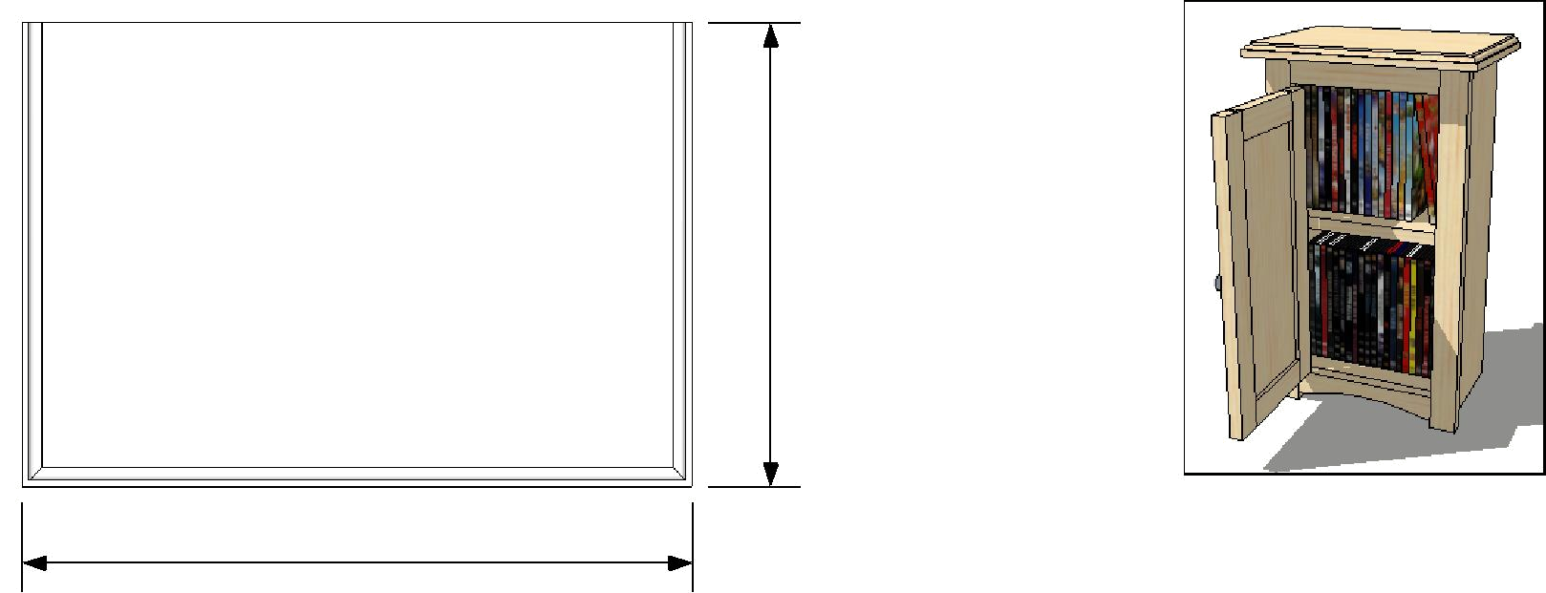

9"

13"
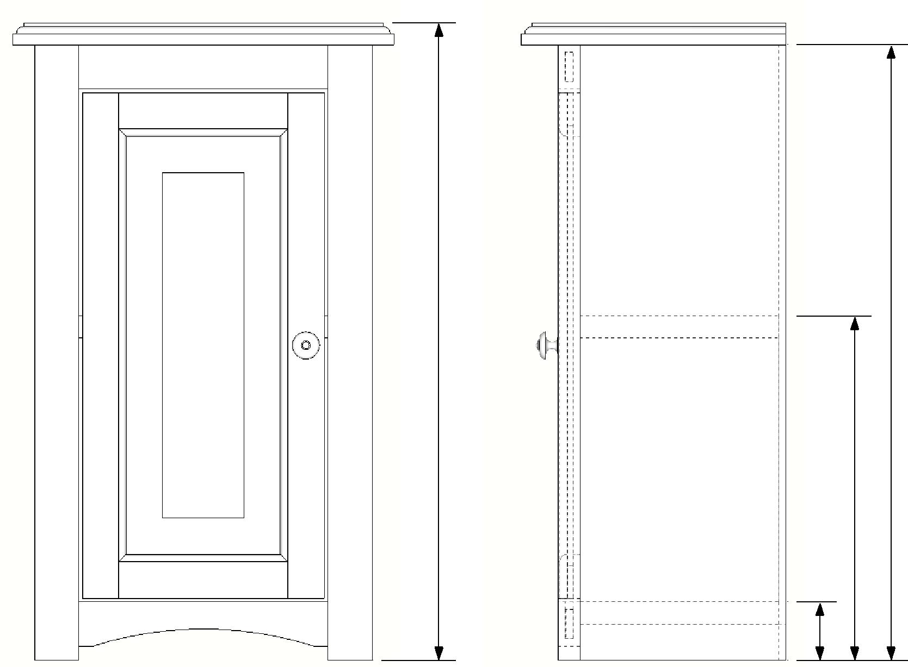

21 3/4"
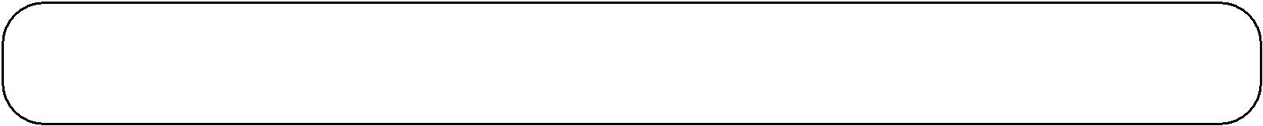

21"

11 3/4"

2"

Pine DVD Cabinet | Scale: | 3":12"
Overview | February 14, 2012

Bill of Materials

 | Description | Parts | Length |  | Width | Th.
 | Description | per Unit | Length |  | Width | Th.
1 | Top | 1 | 13 |  | 9 | 3/4
2 | Si de | 2 | 21 |  | 7 | 3/4
3 | Back - Plywood | 1 | 19 3/4 |  | 9 3/4 | 1/4
4 | Shelf | 2 | 9 3/4 |  | 6 3/4 | 3/4
5 | Face Frame
5.1 | Stiles (vertical) | 2 | 21 |  | 1 1/2 | 3/4
5.2 | Rails (horizontal) | 2 | 9 1/2 |  | 1 1/2 | 3/4
6 | Raised Panel Door
 |  |  | Measure
6.1 | Stiles (vertical) | 2 | opening |  | 1 1/2 | 3/4
6.1 | Stiles (vertical) | 2 | less 1/8" |  | 1 1/2 | 3/4
 |  |  | ?
 |  |  | Measure
6.2 | Rails (horizontal) | 2 | opening |  | 1 1/2 | 3/4
6.2 | Rails (horizontal) | 2 | less 2 3/8" |  | 1 1/2 | 3/4
 |  |  | ?
 |  |  | Measure your opening |  |  | 3/4
6.3 | Door Panel | 1 | less 2 3/8" in length |  |  | 3/4
6.3 | Door Panel | 1 | and width
 |  |  | ?
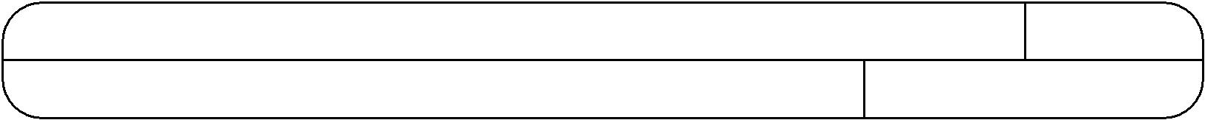

Pine DVD Cabinet

Required Rough Cut Pieces
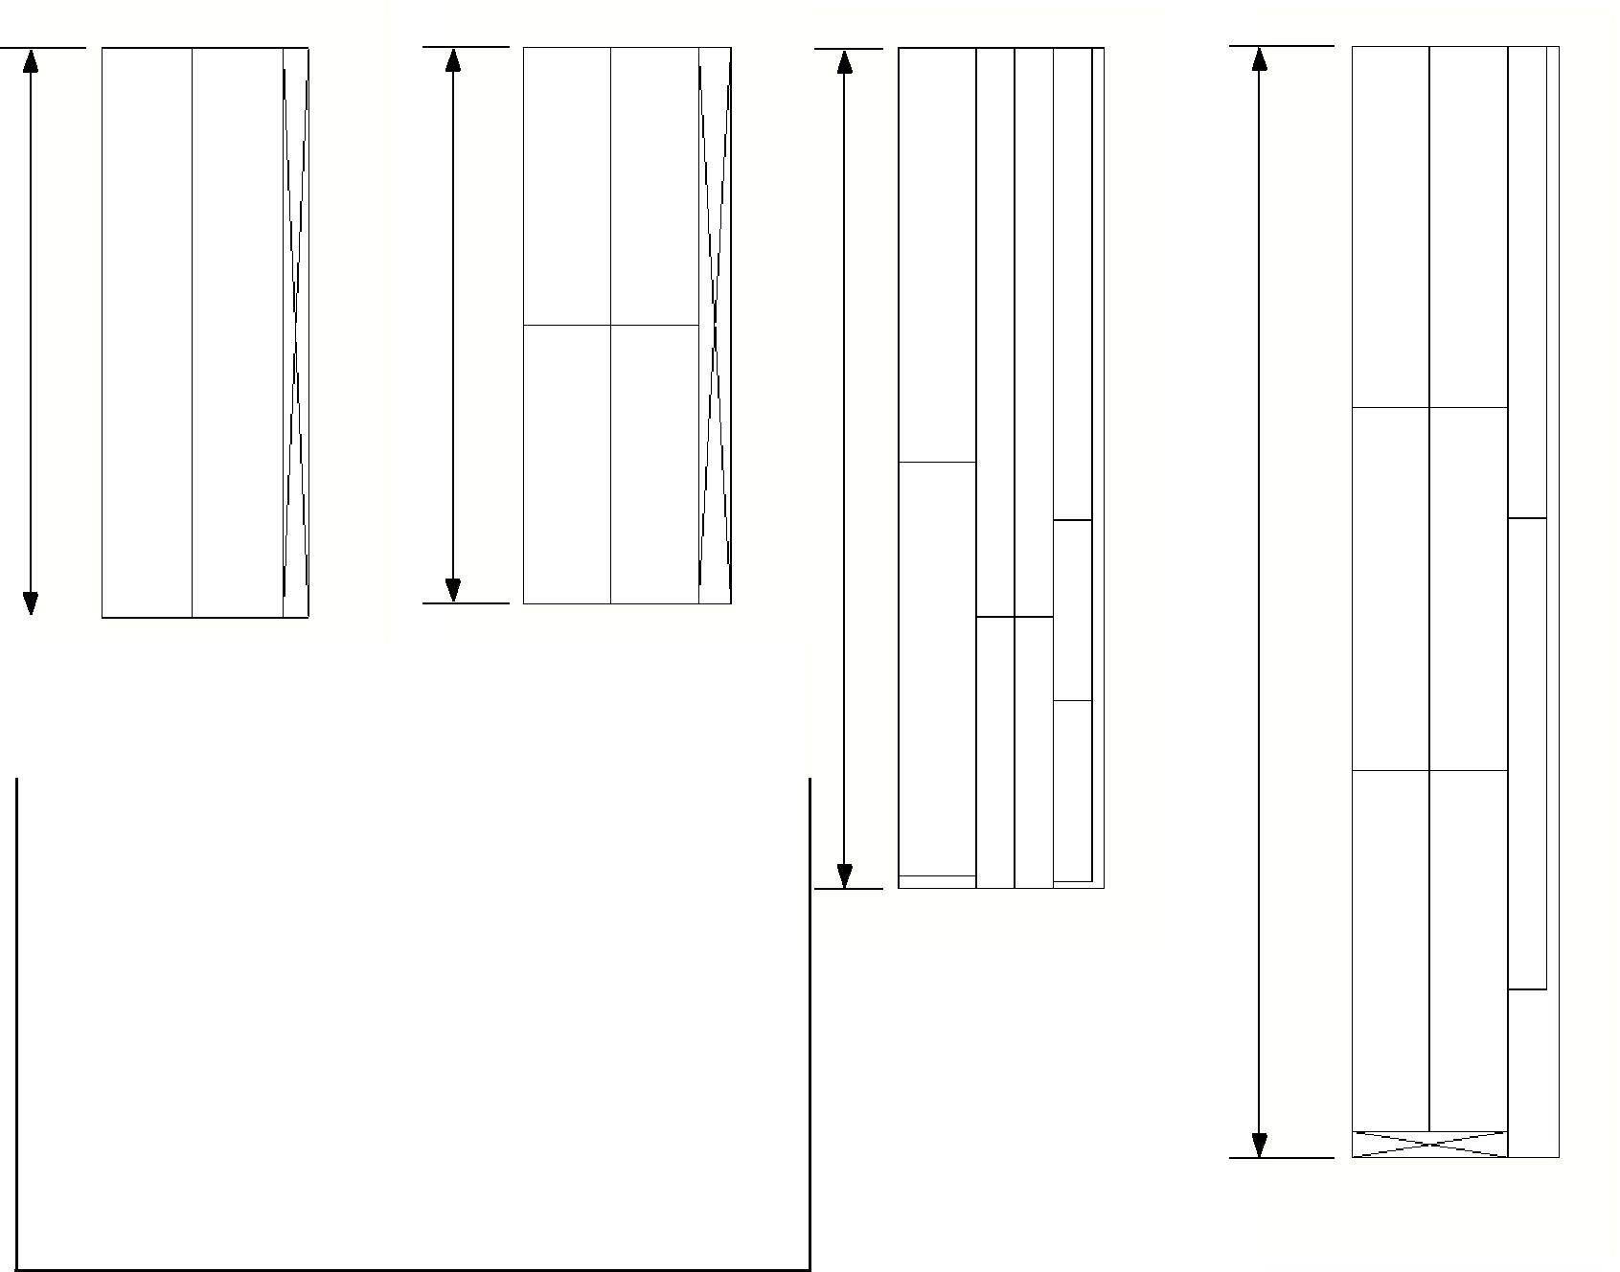

22" | 21 1/2"

32 1/2"

 |  | X | X
 |  | 2 pcs. | 1 pc.
 | "Break Out" Steps

Throughout this project, and indeed with any other woodworking project, the first stage in producing a useable board is the Break Out stage. Listed below are the steps to be followed for every board you produce.

43"

X 1 pc.

X

1 pc.*

*work with partner for this board.

1) Cut a piece of 4/4 pine to rough length as indicated per drawing.

- Joint one face of the board with the cupped face down.

- Joint one edge of the board with the jointed face held tightly against the fence.

- Plane the board to MAX THICK unless otherwise specified. MAX THICK will result in a board with parallel faces around 7/8" thick.

- Move to the table saw and rip your boards as required.

- Once further cut to length (if required), laminate your boards as required with end grains alternating.

 | Description | Parts/Unit | Length | Width | Th.
2 | Side | 2 | 21 | 7 | 3/4

This project requires two identical sides with dados to accept the bottom and middle shelf. Be sure to use a stop block on the dado sled to accurately repeat your dado cuts on both sides.

1. Break out 2 pieces of pine @ 22" long.

- Once at MAX THICK rip each board into 3 1/2" wide pieces. Write your name on the end grain.

- Laminate 2 pairs of boards together @ 7" wide. Remember to alternate the end grain directions and to not glue the two sides together - you require 2 separate sides!

- Once dried for 24 hours, scrape any excess glue off of your panels. Now plane both pieces down to 3/4" thick.

- Square one end on the mitre saw and then cut your pieces to their finished length of 21".

- To cut the rabbet along the back edge of the side, lockout the dado saw and install a 1/4" dado blade. If unsure how to do this ask your instructor. Set the fence of the saw flush the right edge of the dado blade. Set you the blade height to 3/8".

Now run both sides through the saw with the inside face down, and the back edge along the fence.

3 1/2"
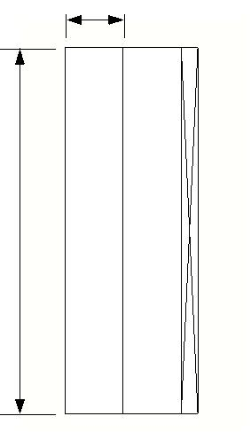

22"

7"
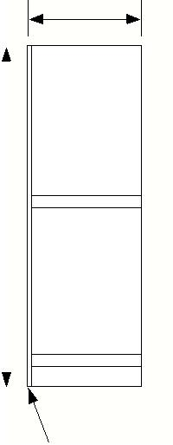
 |  |  | right side shown
21" |  |  | right side shown
 |  |  | eted
 |  |  | compl

1/4" wide 3/8" deep rabbet

Pine DVD Cabinet |  | 1 1/2":12"
Preparing the sides | February 14, 2013

Cutting the dadoes
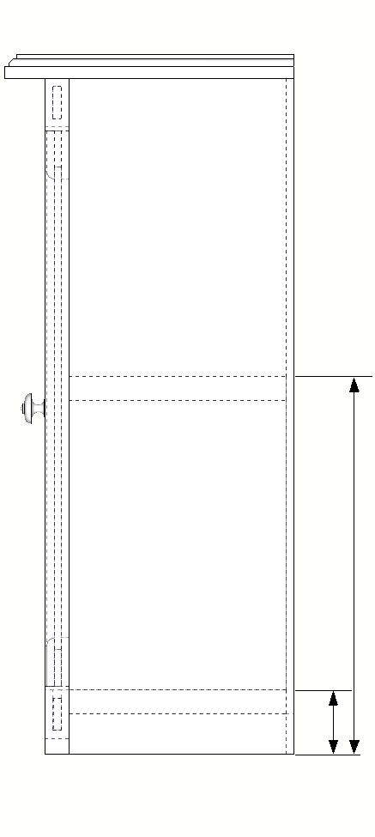
This project requires two identical sides with dados to accept the bottom and middle shelf. Be sure to use a stop block on the dado sled to accurately repeat your dado cuts on both sides.

Steps:

1. Be sure your sides are cut accurately to their final dimension of 21".

- Lock out the machine and install a 3/4" wide dado set into the table saw. If unsure, please ask your instructor.

- Set the height of the blade to cut a

3/8" deep dado.

11 3/4"

2"

- Clamp a stop block against the fence to cut a dado at 2" up from the bottom

edge of the side to the top of the dado. Cut both of your sides with this setup keeping the inside face down on the sled.

- Move the stop block to cut a dado at 11 3/4" from the bottom edge of the side to the top of the dado. Again, cut both sides using this setup. Ensure your name is on both pieces.

 | Description | Parts/Unit | Length | Width | Th.
4 | Shelf | 2 | 9 3/4 | 6 3/4 | 3/4

This project requires two identical shelves. In fact, one will be the bottom while the other will remain a shelf. Be careful when planning to finished thickness - 3/4" exactly please!

1. Break out 1 piece of pine @ 21 1/2" long.

- Once at MAX THICK rip your board into 3 3/8" wide pieces. Write your name on the end grain.

- Laminate these two pieces together @ 6 3/4" wide. Remember to alternate the end grain directions.

- Once dried for 24 hours, scrape any excess glue off of your panel. Now plane it down to 3/4" thick.

- Square one end on the mitre saw and then cut two pieces to their finished length of 9 3/4".
These pieces are now complete. Write your name on the end grain and set aside.

3 3/8"
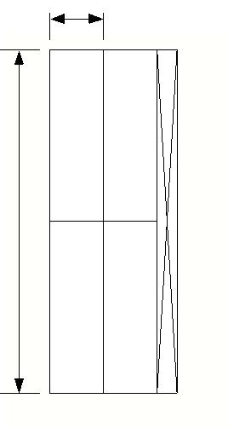

21 1/2"
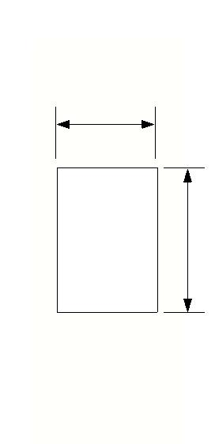

6 3/4"

9 3/4"

Pine DVD Cabinet |  | 1 1/2":12"
Shelf & Bottom | February 14, 2013

 | Description | Parts/Unit | Length | Width | Th.
1 | Top | 1 | 13 | 9 | 3/4

The cabinet top is built by joining several strips of pine together. The required break out must be done with a partner and will result in each

partner getting three pieces to form their top and one door stile.

1. With a partner, break out a piece of pine @ 43" long.

2. Once at MAX THICK rip each board into two strips @ 3" wide. Rip a final strip @ 1 1/2".

3. | Using a mitre saw cut each 3" wide strip into 14" long | 43"
pieces. Each partner will get 3 of these pieces to create their
top!
4. | Cut the remaining 1 1/2" strip into two pieces @ 18 1/4"
long. Each partner gets one of these door stiles. Ensure your
name is written on each piece and set the stiles aside for now.
5. | Laminate your top @ 9" wide, alternating the end grain.
6. After 24 hours scrape away excess glue and plane to 3/4"
thick.
7. | Square one end and then cut it to the final length of 13".

3" | 3"
 | 1 1/2"
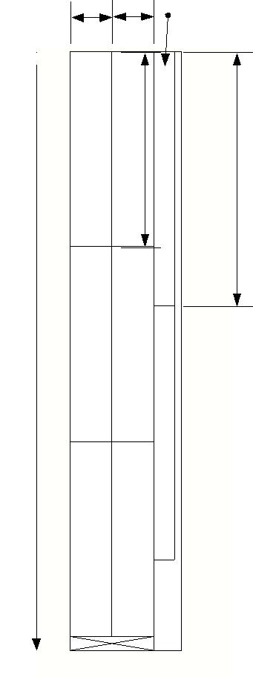

Top | 14" | l e | 1/4"
 |  | Sti | 18

Top | parnter's | Stuff
Top | Your

13"
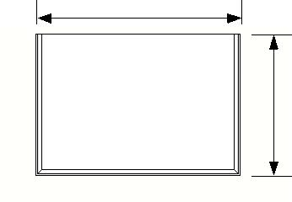

8. Setup the router table with your favourite bit. If you are unsure about how to do this please ask your instructor. Create a decorative edge on three sides, cutting your end grain first.

9"
 |  | 1 1/2":12"
Maki ng the top
Maki ng the top | February 14, 2013

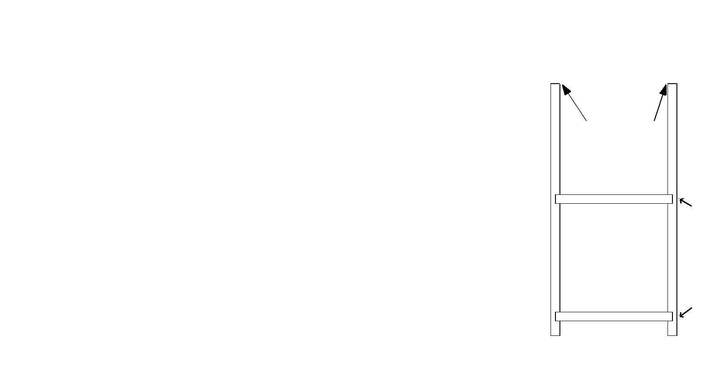
Assembling the Carcass

Before you assemble your carcass sand your sides and shelves up to 220 grit. Be careful not to apply too much glue or else it will end up in hard to reach places!

1. Using the Kreg jig drill two pilot holes on the top, inside edge of each side. Keep them about 1 1/2" back from the front and back edges.

- Lay one of your sides down, inside face up. Apply glue to the dados.

- Insert your shelves into the dados. Make sure the front edges of the shelves are flush to the front edges of your side.

- Apply glue to the other sides' dados and fit that side onto the other end of the shelves. Again be sure to align this side flush to the front edge of the shelves.

- Apply clamps across the shelves and clamp them firmly. This is your last chance to align the front edges of everything.

- Before you allow the glue to set check the carcass for square. Hold a square on the shelves and check it against the side piece. If required you can push and pull as required to get it square.

Kreg jig pilot holes

Appl y clamps across here
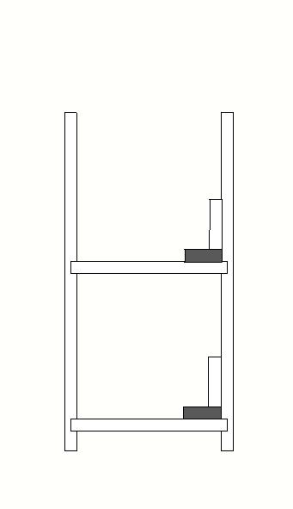

Check for square here

Pine DVD Cabinet |  | 1 1/2":12"
Assembling the carcass | February 14, 2013

 | Description | Parts/Unit | Length | Width | Th.
6.3 | Door Panel | 1 | ~15" | ~6" | 1/2

This piece will require careful attention to detail during break out. Be sure to write your name on every piece and label each piece as to what it is to become. The final dimension of these pieces will depend on your specific cabinet size. Assemble your project before cutting any of these pieces to final size.

1. Break out a piece of pine @ 32 1/4" long.

- Once at MAX THICK rip a strip @ 3" wide. Clearly write your name on the remaining piece and set it aside for now.

- Using a mitre saw cut this 3" wide strip into 16" long pieces.

- Laminate your door panel @ 6" wide, alternating the end grain.

- After 24 hours scrape away excess glue and plane to 1/2" thick.

- Trim both ends square, but do not cut much off. We will come back to the door panel later on. Clearly write your name on it and set it aside until you have your cabinet assembled with the face frame attached.

3"
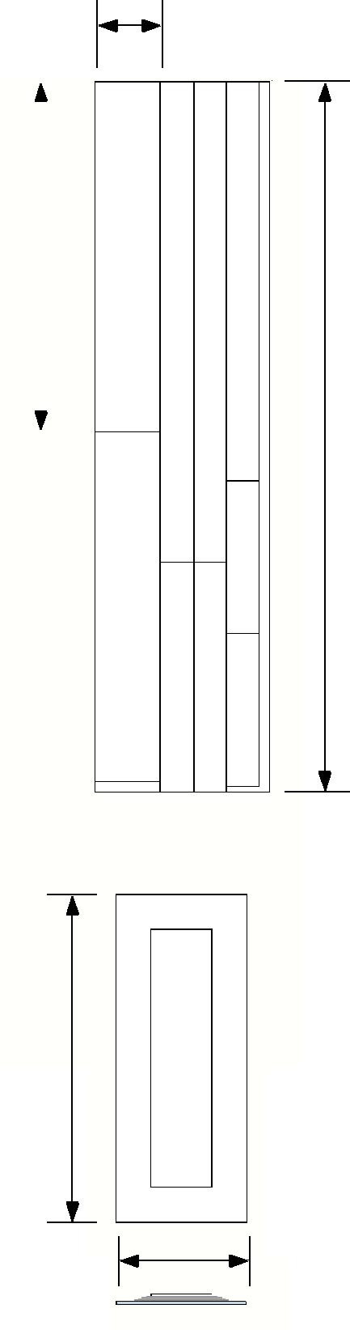

 |  |  | Door Panel | es | Door Stiles
16" |  |  | Door Panel | es | Door Stiles
 |  |  | Door Panel | l | Door Stiles
 |  |  | Door Panel | ti | Door Stiles
 |  |  | Door Panel | S | Door Stiles
 |  |  | Door Panel | e | Door Stiles
 |  |  | Door Panel | m | Door Stiles
 |  |  | Door Panel | a | Door Stiles

Door Panel | Door Rails

____"

___"

32 1/2"

Pine DVD Cabinet |  | 1 1/2":12"
Door Panel & Other parts | February 14, 2013

 | Description | Parts/Unit | Length | Width | Th.
5.1 | Face Frame Stile | 2 | ~21" | 1 1/2" | 3/4
5.2 | Face Frame Rail | 2 | ~9 1/2" | 1 1/2" | 3/4

These pieces come from the offcut of your door panel. They
will require careful attention to detail during break out. Be
sure to write your name on every piece and label each piece as |  |  | es | Stiles
to what it is to become. The final dimension of these pieces |  |  | es | Stiles
 |  |  | l | Stiles
 |  | ti |  | Stiles
will depend on your specific cabinet size. Assemble your |  | S |  | Stiles
 |  | e |  | Door
 |  | m |  | Door
project before cutting any of these pieces to final size. |  | a |  | Door
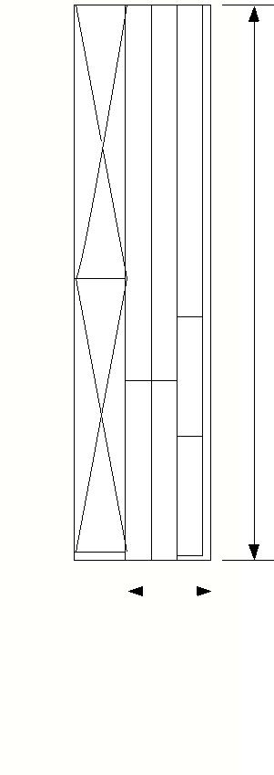
1. Plane your offcut (as shown on the right) to 3/4"

2. Rip two strips @ 1 1/2" wide. Clearly write your name on the remaining
piece and set it aside for now. |  |  |  |  | Rails
3. Using a mitre saw cut each 1 1/2" strip into two pieces. From each piece
 |  |  |  |  | Door
you will get a rail and stile. The face frame stile should be the exact same
length as your sides (awful close to 21" long).
4. Using a mitre saw cut the remaining lengths of the strips to the inside
 |  |  |  |  | 5"
measurement of your cabinet plus 1/2". This should be close to 9 1/2"
long. Verify by measuring your assembled cabinet.
5. Move to the mortising machine to cut mortises in your face frame stiles
as shown below. Lockout the machine and install a 3/8" mortising bit. If you
are unsure about how to proceed please ask your instructor. The tenons
you will be cutting to fit into these mortises will be 1/2" long so set the
depth stop on the machine to cut a 5/8" deep mortise to allow for an easy
fit. |  | 21"
1 3/4" |  |  | 1 1/4"
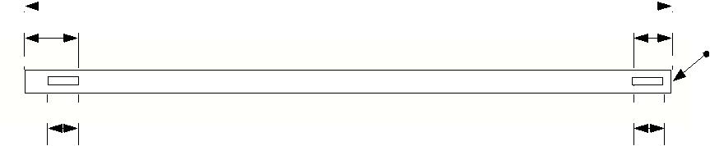
Top of the stile
*scale: 3":12"
1" | 1"

Pine DVD Cabinet |  | 1 1/2":12"
Face Frame Stiles & Rails
Face Frame Stiles & Rails | February 14, 2013

32 1/2"

 |  |  | Description | Parts/Unit | Length |  | Width |  | Th.
 | 5.1 |  | Face Frame Stile | 2 | ~21" |  |  | 1 1/2" | 3/4
 | 5.2 |  | Face Frame Rail | 2 | ~9 1/2" |  |  | 1 1/2" | 3/4
 | These |  | pieces come from the offcut of
 | These |  | pieces come from the offcut of | your door panel. They
 | will require careful attention to detail during break out. Be
 | sure to write your name on every piece and label each piece as |  |  |  |  |  |  |  | es | Stiles
 | to what it is to become. The final dimension of these pieces |  |  |  |  |  |  |  | es | Stiles
 |  |  |  |  |  |  |  |  | l | Stiles
 |  |  |  |  |  |  |  |  | ti | Stiles
 | will depend on your specific cabinet size. Assemble your |  |  |  |  |  |  |  | S | Stiles
 |  |  |  |  |  |  |  |  | e | Door
 |  |  |  |  |  |  |  |  | m | Door
 | project before cutting any of these pieces to final size. |  |  |  |  |  |  |  | a | Door


1. Grab your face frame rails and move to the dado sled. Lockout the machine and install a 1/2" dado blade in the saw. If you are unsure how to do this safely, please ask your instructor.

2. Set the blade height just shy of 3/16". Cut all four sides on one | Rails
 | Door
end of a rail and test fit with the oak test blocks at the dado saw. | Door
3. If the tenon you just cut will not fit, grab hold of the blade
height adjustment knob at the front of the machine and, with | 5"
both hands on the wheel, "turn the car left" to raise the blade.
Only turn the blade about one inch at a time and recut your piece
until it fits snugly in the test mortise.

4. Once set, cut the rest of the tenons on your face frame rails.

1/2"
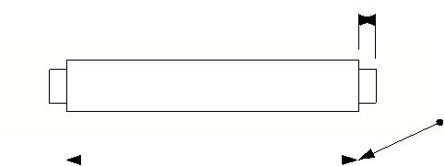

*scale: 3":12"
 | Inside measure of your cabinet
____" | less 1/2".

32 1/2"

Pine DVD Cabinet |  | 1 1/2":12"
Face Frame Stiles & Rails continued | February 14, 2013

Assembling the Face Frame

Your face frame should end up with a 1/2" overhang over the carcass. Before you apply glue though be sure to dry fit your parts and ensure the top of the frame is flush. Feel free to cut a "scallop" in the bottom rail for decoration if you'd like.

1. Dry fit your face frame. Check that the top rail sits flush to the top of your stiles. If not you may have to carefully trim either the top or bottom of the tenons with a chisel. Also check that the bottom rail sits flush to the bottom shelf of your carcass. Simply set your dry fit face frame onto the face of the carcass to verify. Again, you can trim the tenons on the bottom rail if need be.
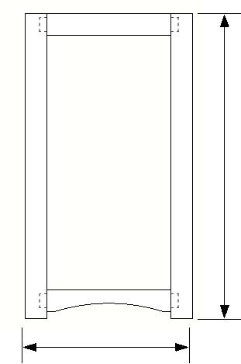
2. Grab your face frame rails and apply glue to the
tenons. | 11 1/2"

- Apply some glue to the mortises and assemble the frame. Use a clamp across the top rail, and one across the bottom rail.

- Once dried, use biscuits to apply the sanded face frame onto the carcass. Ask your instructor for help with this step.

21"

Pine DVD Cabinet |  | 1 1/2":12"
Face Frame assembly | February 14, 2013

 | Description | Parts/Unit | Length | Width | Th.
6.1 | Door Stiles (vertical) | 2 | ? | 1 1/2 | 3/4
6.2 | Door Rails (horizontal) | 2 | ? | 1 1/2 | 3/4
6.3 | Door Panel | 1 | ? | ? | 1/2

Once you have all of your door pieces cut to rough length and your assembled carcass has the face frame attached you can move onto creating the door. Your door will be sized about 1/8" less overall (in length and width) than the size of the opening of your face frame.

Rai l 
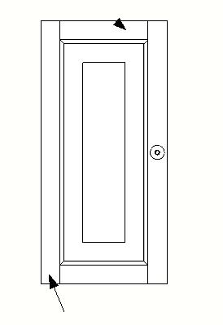

1. Cut your stiles to finished length. This can be measured using the inside measure of the height of the face frame less 1/8".

- Cut your rails to finished length. This can be measured using the inside measure of the width of the face frame less 2 3/8".

- Setup the router table with the stick cutting bit to cut the panel grove and patterned edge on the inside of the rails and stiles. Please ask your instructor for assistance.

- Setup the router table with the cope cutting bit to cut the end grain of your rails. Once cut, dry fit your door together and measure the overall width. If needed now is the time to cut your rails shorter and re-router them.

- When the door frame fits your carcass measure the overall size of the door. The door panel should be 2 3/8" shorter in length and width.

Sti l e
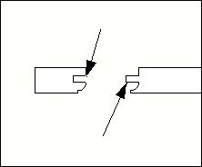

Stick cut

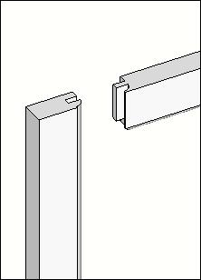
Cope cut

Assembling the Door

Once your door rails and stiles are cut to size and your door panel fits nicely you are ready to glue. Just remember that the door is a floating panel. The door system is designed to allow for expansion and contraction, so do not apply any glue to the door panel.

1. Sand all of the door parts; stiles, rails, and the door panel up to 220 grit.

- Apply glue in the panel groove of one stile where the rails will be.

- Apply glue to the cope cut of one rail; place it into the stile, then put the door panel in place.

- Apply glue to the cope cut of the other rail and put it in place.

- Apply glue to the final stile and fit it to complete assembly of the door.

- Use two clamps to ensure a tight fit.

Rai l

Sti l e

Stick cut

Cope cut

Pine DVD Cabinet |  | 1 1/2":12"
Door Assembly | February 14, 2013

Completing your Cabinet

The final step in constructing your cabinet is to cut a plywood back. Apply a bit of glue to your rabbets and along the back edge of your shelves and tack the back in place with a few 1" nails.

Reflection

1. What would you do different if you had to build this project again?

- What did you learn that surprised you during this process?

- How would you change your finished project to make it better?

Woodworking Technology – TWJ3E
DVD Cabinet
Peer and Self-Assessment
Criteria | Level 4 | Level 3 | Level 2 | Level 1 | My Level | Peer  Level
Knowledge and Understanding
How is my knowledge of joinery? | High level of joinery knowledge. Can identify all joints’ strengths and weaknesses | Good degree of joinery knowledge. Can identify most joint’s strengths and weaknesses | Average degree of joinery knowledge. Can identify a few joint’s strengths and weaknesses | Minimal degree of joinery knowledge. Only able to identify a few strengths or weaknesses
What level am I at when selecting tools? | I am very confident when selecting which tool to use for specific applications | I am confident selecting tools, but need some assistance for specific applications | I know when and how to use most tools but often seek assistance for specific applications | I know when and how to use a few tools and I seek assistance constantly
Thinking and Inquiry
What level am I working at when it comes to personal protective equipment? | I wore my PPE everyday with no reinforcement needed | I wore my PPE everyday but needed reinforcement a few times | Most days I wore my PPE with reinforcement | I was reinforced to wear my PPE constantly
Communication
How is my level of terminology of joinery and tools? | I am able to correctly identify all joinery and tools used | I identify most joinery and tools used | I identify a few of the joinery and tools used | I am unable to identify most of the joinery and tools used
Application
How well was my Mortise and Tenon executed? | High level of precision, joint was very tight with no gaps | Joint was constructed well with slight hairline gaps | Joint assembled with major gaps visible | Joint did not assemble
How well was my Dado Joint executed? | Shelves are very tight with no gaps | Shelves fit snuggly with slight hairline gaps | Shelves fit with some gaps | The shelves are very loose and have major gaps
Student:______________________ Date:________________

My Achievement level: ________________ Peer Achievement Level:_________________

Submitted by:________________________________

Activity 1.2: Joinery 101
Time: 3 hours

Description
Students will use scrap pieces of wood to practice their joinery skills and techniques in preparation for the joint frame project. Students may practice any joint as many times as required within the given time restraints of the activity.

Strand(s) & Learning Expectations
Strand(s): Fundamentals, Skills, Technology, the Environment, and Society, Professional Practice and Career Opportunity
Overall Expectations
A. 2, 3, / B. 4, / C. 1, / E. 1

Specific Expectations
A 2.2, 2.3, 3.2, / B 4.3, / C 1.4, 1.6, / E 1.4

Accommodations
The teacher consults individual student IEPs for specific direction on accommodation and adapts the activity and teaching strategies to meet the needs of individual students. Students’ individual needs may be accommodated through an adaptation of the design and/or production stages of the activity.

Joinery 101
Activity Plan

Technological Education Discipline: Woodworking Technology – TWJ3E

Activity Name: Joinery 101

Unit #: 4 - Joinery

Activity #: 2

Description: Students will use scrap pieces of wood to practice their joinery skills and techniques in preparation for the joint frame project. They will be given a hand-out with written instructions as well as demonstrations on how to perform the various joints. Afterwards, they will be given class time to work on the joints. Students may practice any joint as many times as required within the given time restraints of the activity.

Assessment and Evaluation: Assessment As Learning and Assessment For Learning. These assessments will be supported by a checklist and anecdotal comments about the students work and how improvements might be made. These skill areas will be assessed; Knowledge and Understanding, Communication, Application

Overall Curriculum Expectations: A. 2, 3, / B. 4, / C. 1, / E. 1

Specific Curriculum Expectations: A 2.2, 2.3, 3.2, / B 4.3, / C 1.4, 1.6, / E 1.4

Prior Learning: All students should have some prior knowledge of: Safety in the classroom, Personal safety knowledge (PPE), Safe use of the machines and hand tools, Knowledge of accurate measurement

Enduring Understandings and Essential Skills: Problem Solving, Various Joinery Techniques, Knowledge and Use of Jigs,

Activity Procedure: Students will take scrap pieces of wood and practice their joinery skills and techniques in preparation for the Joint-Frame Project. A hand-out will be provided with instructions on how to cut each individual joint. The teacher will also provide a brief demonstration of how to cut each joint.

Materials: Scrap pieces of wood, pencil, dowels, wood plugs

Tools and Equipment: Table saw, Mitre Saw, Mortiser Machine, Marking Gauge, Combination Square, Tape Measure, Biscuit Joiner, Kreg Jig, Dado Blades, Table Saw Sled, Chisels, Backsaw, Drill and Drill Bits, Countersink, Flush-Cut Saw, Wood File

Accommodations and Modifications: If necessary, extra time can be allotted for students and repeating instructions for clarification. Large print handouts.

Terminology, Literacy and Numeracy: Math with metric and imperial measuring systems. Students will be reading and following instructions.
Terminology:

Additional Resources: Students may wish to follow the hand-out given on the various types of joinery for additional information. Students will be required to review the safe operation procedures handout for all tools and equipment used.

Activity Review: (Review the activity after it has been completed by students, what, could be improved?)

__________________________________________________________________________________________________________________________________________________________________________________________________________________________________________________________________________________________________________________________________________________________________________________________________________________________________________________________________________________________________________________________________________________________________________________________________________________________________________________________________________________________________________________________________________________________________________________________________________________________________________________________________________________

(This is the Hand-out students will receive along with demonstrations)

Joinery 101
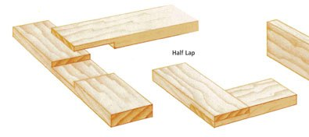
- Half-Lap
Half-Lap: Lap joints are created when two pieces of wood overlap one another at a right angle. Both pieces may also be notched to half of their thickness, allowing them to fit into each other. These lap joints are known as half-lap joints. There are various ways of cutting a half-lap. The easiest way to cut a half-lap is using the Dado Sled. Students will measure half the thickness of their pieces then set the blades slightly lower to that measurement. They will then overlap their pieces, ensuring it is square, and mark the intersections. Students will use the sled and cut on the inside of their lines, checking each time to ensure it fits together snug and not cut too wide. They will also slightly raise the blade until once assembled; the pieces are completely flush with one another.

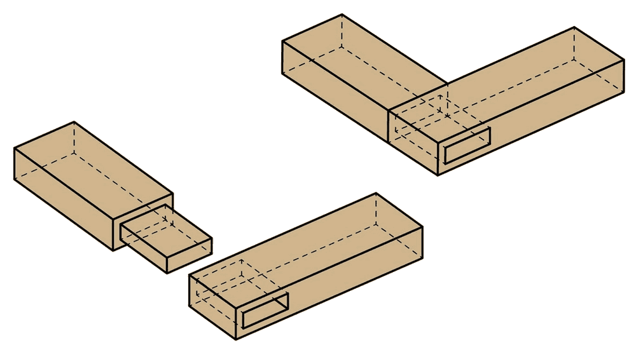
-Through Mortise and Tenon
Through Mortise and Tenon: Students have experience cutting Mortise and Tenon’s through working on their face frame of the DVD Cabinet. Though what they cut was a Stub Mortise and Tenon. A Through Mortise and Tenon is when the Tenon goes all the way through the Mortise so you can see it on the other side. Sometimes, wedges or dowels may be inserted in the end of the mortise as a decorative feature. The process to cut the Through Mortise and Tenon is fairly the same. When cutting the Mortise, students will cut all the way through their piece of wood. Then when cutting their Tenon’s, students may make the Tenon’s longer than the mortise than use a Flush Cut Saw to trim off the remaining piece on the outside once inserted. To finish it off, students may have to sand the end in order to make sure everything is flush.

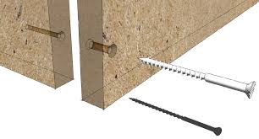
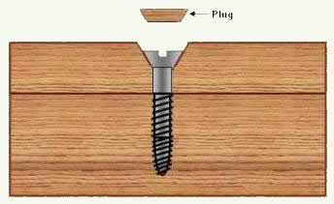

Countersunk Screws: Using countersunk screws for joints is one of the easiest methods of joining material. Students will first begin by holding or clamping their pieces together. They will then drill a hole through both pieces wood with a countersink bit that also has a drill bit that is the diameter of the screw’s shank. After the hole has been drilled, students will use a screwdriver to drive the screw into the hole. They will continue to drive the screw hole until the head is about 1/8” to ¼” below the surface. They will then glue and insert a wood plug. If the wood plug protrudes, students will use a flush cut saw, then sand the plug until it is flush.

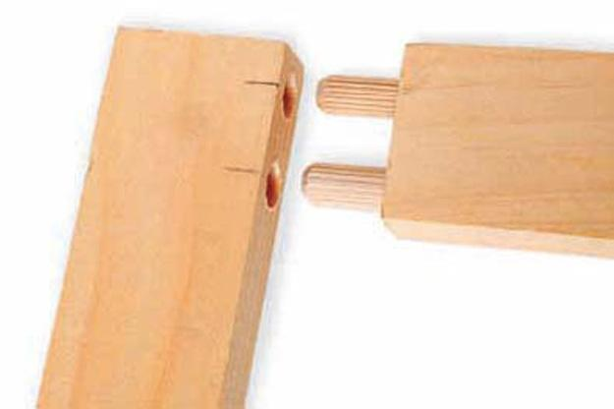
-Dowel Joint

Dowel Joint: A Dowel Joint is also one of the easiest joint to perform yet also hides the mechanical fasters quite well. To make a Dowel Joint, student will mark the desired center of the hole(s) on both pieces. They will then drill a hole with a bit that is the width of the desired dowel. Students will drill slightly deeper than half the length of their dowel in both of their pieces. Once the hole has been drilled, they will insert the dowel in the hole(s) and assemble their joints.
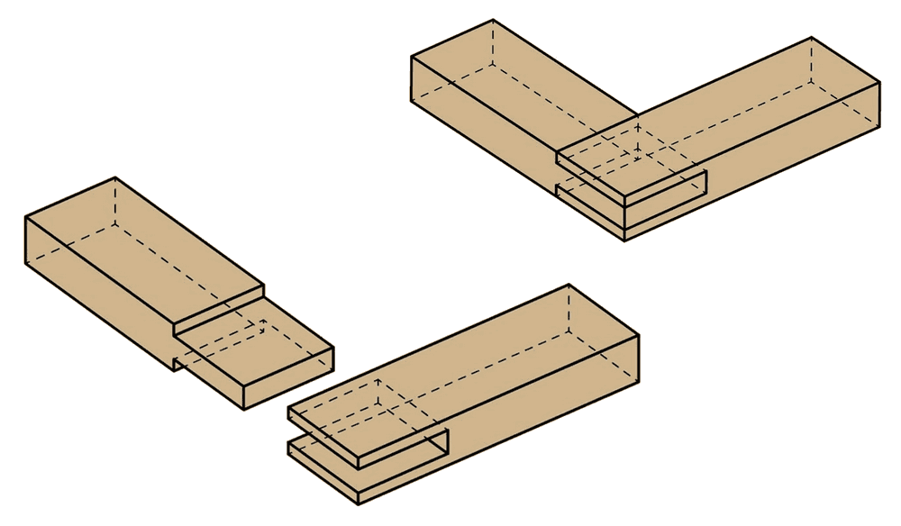
-Open Mortise and Tenon
Open Mortise and Tenon: The Open Mortise and Tenon is again, very similar to the Through Mortise and Tenon. The open end on the top of the joint is what separates them both. To cut an Open Mortise and Tenon, students will follow the same process as cutting the Through Mortise except for one step. When cutting their mortise, students will begin by cutting the inside of their mortise, and then move their piece along until they cut right through the end.
Pin
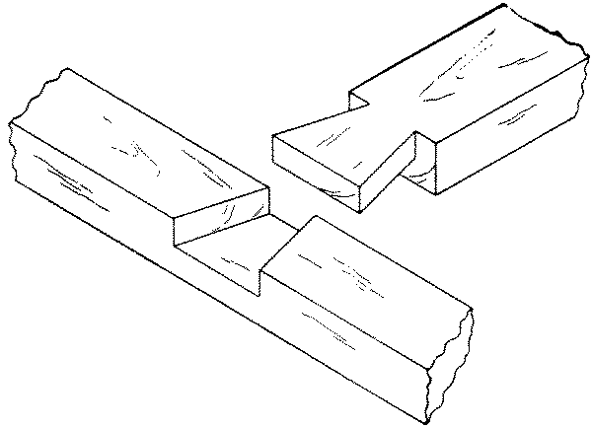
- Dove Tail Lap
Tail (slot)
Dove Tail Lap: Dove tail joints are one of the strongest joints used in woodworking due to their interlocking wedge design. They are also very pleasing to the eye and can enhance the quality to any project. Though due to this design, they are more difficult to construct and require more time to be made if made by hand without a router bit. To construct a dove tail lap joint, students must first layout the pin of their Dove Tail. Once it has been laid-out, students will put their piece in a clamp and use a handsaw to cut the sides of their pin. Students may wish to cut on the outside of their lines then use either chisels, wood files, or sandpaper to smooth and straighten the sides. Once the sides have been cut out, they will measure and layout half the thickness of their piece. They will then cut their pin in half on the outside of the line. This will allow students again to sand or file their pin to ensure it is flat. Once the pin has been laid-out, students will place it on the other piece of the wood and mark the intersection. Students will then clamp the piece that has been marked and layout the thickness of their pin that they had cut. Once everything has been laid out, students will begin to cut their tail on the inside of their lines and only cutting slightly above their depth line. Once they have made those two cuts, students will make several cuts on the inside of the lines and again only cutting slightly above their depth line. Once they have several cuts made, students will use a chisel to cut out all of the remaining little pieces. They will continue to cut the sides of their tails until it fits snuggly into their pin. Once the pin fits snuggly into their tail, they will chisel, file, and sand their tails until the pieces are flush with another when assembled. If the pin protrudes the tail, students can use flush saws then sand the pin until it is flush on the end.

Joinery 101 – Joinery Checklist  Student Name:_____________________________  Date:____________________________________  Class:_____________________________________ | Student worked safely on the tools and machines | Student uses proper terminology when describing tools and joints | Joint assembles very tight with no gaps | Joint assembles with slight gaps | Joint assembles loosely with major gaps
Joints
Half-Lap Joint
Through Mortise and Tenon
Countersunk Screw
Dowel Joints
Open Mortise and Tenon
Dove Tail Lap Joint

Comments:

Half-Lap Joint:
____________________________________________________________________________________________________________________________________
Through Mortise and Tenon:
____________________________________________________________________________________________________________________________________
Countersunk Screws:
____________________________________________________________________________________________________________________________________
Dowel Joints:
____________________________________________________________________________________________________________________________________
Open Mortise and Tenon:
____________________________________________________________________________________________________________________________________
Dove Tail Lap Joints:
____________________________________________________________________________________________________________________
Activity 1.3: Joint-Frame Project
Time: 3 hours

Description
Combining the knowledge of joinery learnt in the previous activities, students will construct a Joint-Frame. The Joint-Frame will consist of various joints that will be used to assemble it. Students will be evaluated on their knowledge and skillset of joinery.

Strand(s) & Learning Expectations
Strand(s): Fundamentals, Skills, Technology, the Environment, and Society, Professional Practice and Career Opportunity
Overall Expectations
- 2, 3 / B. 3, 4 / C. 1 / E. 1

Accommodations
The teacher consults individual student IEPs for specific direction on accommodation and adapts the activity and teaching strategies to meet the needs of individual students. Students’ individual needs may be accommodated through an adaptation of the design and/or production stages of the activity.

Joint-Frame Project
Activity Plan

Technological Education Discipline: Woodworking Technology – TWJ3E

Activity Name: Joint-Frame Project

Unit #: 4 - Joinery

Activity #: 3

Description: Combining the knowledge of joinery learnt in the previous activities, students will construct a Joint-Frame. The Joint-Frame will consist of various joints that will be used to assemble it. Students will be evaluated on their knowledge and skillset of joinery.

Assessment and Evaluation: Assessment Of Learning. This assessment will be supported by a rubric that will be given to the students to view over beforehand. These skill areas will be assessed; Knowledge/Understanding, Thinking /Inquiry/Problem Solving, and Application

Overall Curriculum Expectations: A 2, 3 / B3, 4 / C 1 / E 1

Specific Curriculum Expectations:

Prior Learning: Students will receive prior knowledge from the prior activities: Safety in the classroom, Personal safety knowledge (PPE), Safe use of the machines and hand tools, Knowledge of accurate measurement, Knowledge and use of jigs and sleds, Various joinery techniques and procedures, Joinery Layout

Enduring Understandings and Essential Skills: Problem Solving, Various Joinery Techniques, Knowledge and use of jigs, Joinery Layout

Activity Procedure: The material will already be dressed to the required measurements because students will not be evaluated on those woodworking processes and this will also allow students maximum time to construct and assemble their joint frames. Students will first be briefed on the Joint-Frame project by receiving the hand-out followed by the rubric. This will be their opportunity to clarify any information and ask any questions. Students may begin on any joint in no particular order. Students may begin with any joint, in any particular order. They should keep in mind the processes of some of the joints and the availability of certain specific tools. Students should also be reminded not to glue their Joint-Frames, except for the wood plug, in order to allow the teacher to fully inspect their joints. Once every student is satisfied and completely understands the project, they may begin to construct their project.

Materials: Wood, pencil, screws, dowels, wood plugs

Tools and Equipment: Table saw, Mitre Saw, Mortiser Machine, Marking Gauge, Combination Square, Tape Measure, Biscuit Joiner, Kreg Jig, Dado Blades, Table Saw Sled, Chisels, Backsaw, Drill and Drill Bits, countersink

Accommodations and Modifications: If necessary, extra time can be allotted for students and repeating instructions for clarification. Large print handouts.

Terminology, Literacy and Numeracy: Math with metric and imperial measuring systems. Students will be reading and following instructions.
Terminology:

Additional Resources: Students may wish to follow the hand-out given on the Joint-Frame Project for additional information. Students will be required to review the safe operation procedures handout for all tools and equipment used.

Activity Review: (Review the activity after it has been completed by students, what, could be improved?)

__________________________________________________________________________________________________________________________________________________________________________________________________________________________________________________________________________________________________________________________________________________________________________________________________________________________________________________________________________________________________________________________________________________________________________________________________________________________________________________________________________________________________________________________________________________________________________________________________________________________________________________________________________________

Joint-Frame Project

Students will construct their Joint-Frame to the specifications of the hand-out. They will be told not to glue their frame, except for the wood plug, in order to allow the teacher to fully inspect their joints. They will also be given the rubric beforehand to consult the success criteria.

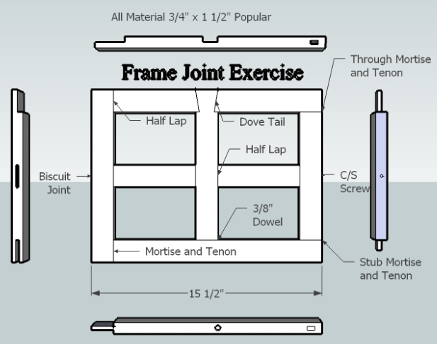
Pine

Joint-Frame Project
Summative Rubric
Criteria | Level 4 | Level 3 | Level 2 | Level 1 | Points
Knowledge and Understanding Overall Expectations assessed E1
Demonstrates an understanding of health and safety regulations and practices specific to woodworking | Always wears proper PPE with no reinforcement when working | Wears proper PPE with minor reinforcement when working | Needs some reinforcement to wear PPE when working | Reluctant and needs constant reinforcement to wear PPE when working
Thinking and Inquiry Overall Expectations assessed A2, B3
Describe woodworking tools, equipment, and techniques, and use the safely | Very safe and constantly follows safe procedures by using guards, fences, jigs, sleds and push sticks | Properly follows safe procedures by using guards, fences, jigs, sleds and push sticks | With some reminders follows safe procedures by using guards, fences, jigs, sleds and push sticks | Is very unsafe and rarely follows safe procedures by using guards, fences, jigs, sleds and push sticks
Plan efficiently and effectively fabrication and assembly of the components of woodworking projects | Demonstrates a high level of understanding when laying out joints and following procedures | Thoroughly lays out joints and needs assistance laying out a few joints | Needs assistance laying out most joints | Great difficulty and needs help with step-by-step instructions on laying out joints
Communication Overall Expectations assessed A3,
Use correct terminology related to woodworking and the materials, tools, equipment, and process involved | Excellent repertoire of terminology. Describes all processes, tools, and measurements | Average repertoire of terminology. Describes most processes, tools, and measurements | Sporadic repertoire of terminology when describing processes, tools, and measurements | Insufficient repertoire of terminology. Unable to identify many processes, tools, and measurements
Application Overall Expectations assessed C1, B4,
Fabricate and assemble custom woodworking projects safely, accurately, and efficiently | Product shows high degree of skill and accuracy. Joints are very tight. | Product shows skill and accuracy, minor improvements can be made | Product shows an effort of skill and accuracy. Improvements can be made | Product shows little to no degree of skill and accuracy
Apply the mathematical skills required in the design and construction of woodworking projects | Joint-Frame is accurately construct and assembled to the exact measurement and specifications | Joint-Frame is efficiently constructed and assembled. Most of the measurements are to the correct specifications | Joint-Frame is constructed and assembled with minor precision. A few of the measurements are to the correct specifications | Joint-Frame is very imprecise. None of the measurements are to the correct specifications
Student:______________________ Final Mark /48 + 48 completion = ______/96
Comments:______________________________________________________________________________________________________________________________________

